Practical 1
Part A — Practice Programs
- Vending machine
CODE:
import java.util.Scanner;
public class VendingMachine
{
enum Coin
{
ONE, TWO, FIVE, TEN
}
public static void main(String[] args)
{
int snackPrice = 15;
int totalAmount = 0;
int coinValue = 0;
Scanner sc = new Scanner(System.in);

while (totalAmount<snackPrice)
{
System.out.print("Enter coin (ONE, TWO, FIVE, TEN): ");
String input = sc.next();
Coin coin = null ;
switch (input)
{
case "ONE":
coin = Coin.ONE;
break;
case "TWO":
coin = Coin.TWO;
break;
case "FIVE":
coin = Coin.FIVE;
break;
case "TEN":
coin = Coin.TEN;
break;
default:
System.out.println("Invalid Coin!");
continue;
}
switch (coin)
{
case ONE:
coinValue=1;
break;
case TWO:
coinValue=2;
break;
case FIVE:
coinValue=5;
break;
case TEN:
coinValue=10;
break;
}
totalAmount += coinValue;
System.out.println("Total paid: " + totalAmount);
}
System.out.println("Paid. Change: " + (totalAmount-snackPrice));
sc.close();
}
}
OUTPUT:
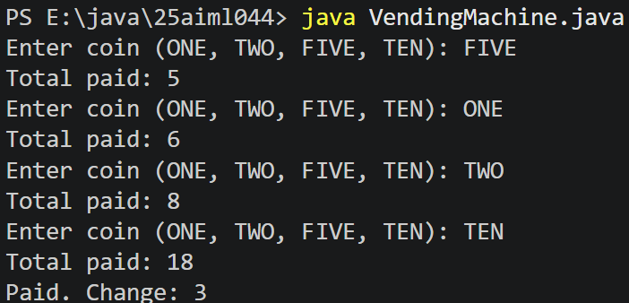

- Toll booth
CODE:
import java.util.Scanner;
public class TollBooth
{
record Vehicle(String number, String type){}
public static void main(String[] args)
{
Scanner sc = new Scanner(System.in);
int totalToll=0;
int bikeCount=0;
int carCount=0;
int truckCount=0;
while(true)
{
System.out.print("Enter vehicle number (or done to stop): ");
String number = sc.next();
if (number.equals("done"))
{
break;
}
System.out.print("Enter vehicle type (bike/car/truck): ");
String type = sc.next();
Vehicle vehicle = new Vehicle(number, type);
switch (vehicle.type())
{
case "bike":
totalToll += 20;
bikeCount++;
break;
case "car":
totalToll += 50;
carCount++;
break;
case "truck":
totalToll += 150;
truckCount++;
break;
default:
System.out.println("Invalid vehicle type!");
}
}
System.out.println("Total toll: " + totalToll);
if(bikeCount >= carCount && bikeCount >= truckCount)
{
System.out.println("Most frequent: bike");
}
else if(carCount >= bikeCount && carCount >= truckCount)
{
System.out.println("Most frequent: car");
}
else
{
System.out.println("Most frequent: truck");
}
sc.close();
}
}

OUTPUT:
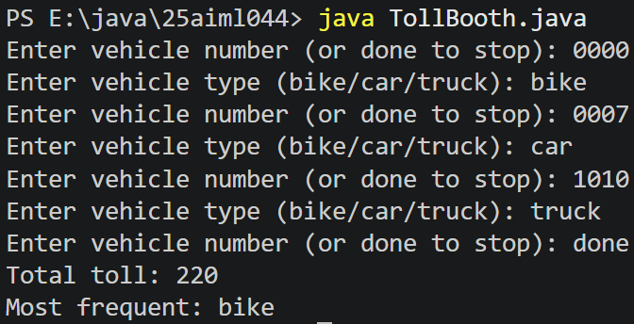

- Rock-Paper-Scissors-Lizard-Spock (RPSLS)
CODE:
import java.util.Random;
import java.util.Scanner;

public class RPSLS
{

enum Move
{
ROCK, PAPER, SCISSORS, LIZARD, SPOCK
}

static int winner(Move a, Move b)
{

if (a == b)
return 0;

switch (a)
{

case ROCK:
if (b == Move.SCISSORS || b == Move.LIZARD)
return 1;
else
return -1;

case PAPER:
if (b == Move.ROCK || b == Move.SPOCK)
return 1;
else
return -1;

case SCISSORS:
if (b == Move.PAPER || b == Move.LIZARD)
return 1;
else
return -1;

case LIZARD:
if (b == Move.PAPER || b == Move.SPOCK)
return 1;
else
return -1;

case SPOCK:
if (b == Move.ROCK || b == Move.SCISSORS)
return 1;
else
return -1;
}

return 0;
}

public static void main(String[] args)
{

Scanner sc = new Scanner(System.in);
Random random = new Random();

int playerScore = 0, computerScore = 0;

for (int i = 1; i <= 5; i++)
{

System.out.println("\n---Round " + i + "---");
System.out.println("1. ROCK");
System.out.println("2. PAPER");
System.out.println("3. SCISSORS");
System.out.println("4. LIZARD");
System.out.println("5. SPOCK");
System.out.print("Enter your choice: ");

int choice = sc.nextInt();

Move player = null;

switch (choice)

{
case 1:
player = Move.ROCK;
break;
case 2:
player = Move.PAPER;
break;
case 3:
player = Move.SCISSORS;
break;
case 4:
player = Move.LIZARD;
break;
case 5:
player = Move.SPOCK;
break;
default:
System.out.println("Invalid choice");
i--;
continue;
}

int computerChoice = random.nextInt(5) + 1;
Move computer = null;

switch (computerChoice)
{
case 1:
computer = Move.ROCK;
break;
case 2:
computer = Move.PAPER;
break;
case 3:
computer = Move.SCISSORS;
break;
case 4:
computer = Move.LIZARD;
break;
case 5:
computer = Move.SPOCK;
break;
}

System.out.println("Your Move: " + player);
System.out.println("Computer Move: " + computer);

int result = winner(player, computer);

if (result == 1)
{
System.out.println("You win this round.");
playerScore++;
}
else if (result == -1)
{
System.out.println("Computer wins this round.");
computerScore++;
}
else
{
System.out.println("Round Tie.");
}
}

System.out.println("\nFinal Score");
System.out.println("You: " + playerScore);
System.out.println("Computer: " + computerScore);

if (playerScore > computerScore)
System.out.println("You win " + playerScore + "-" + computerScore);
else if (computerScore > playerScore)
System.out.println("Computer wins " + computerScore + "-" + playerScore);
else
System.out.println("Match Tie " + playerScore + "-" + computerScore);
sc.close();}
}
OUTPUT:
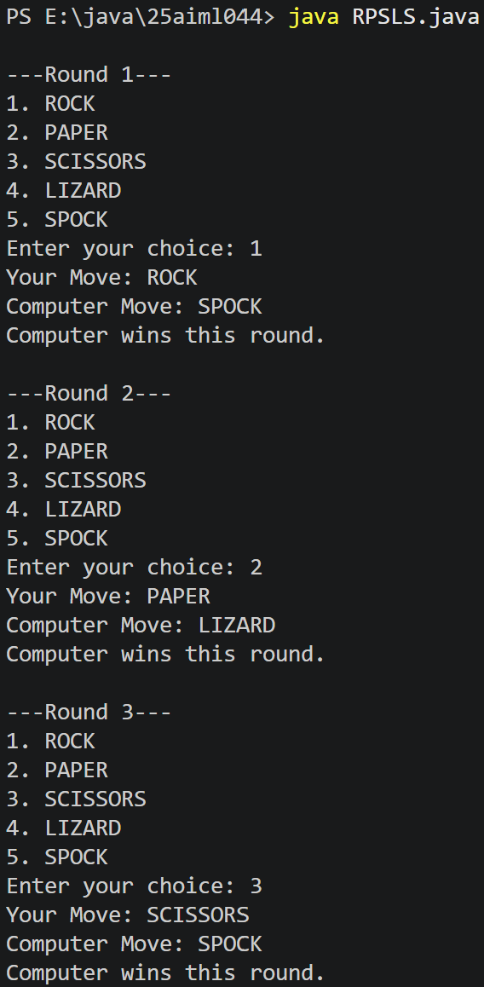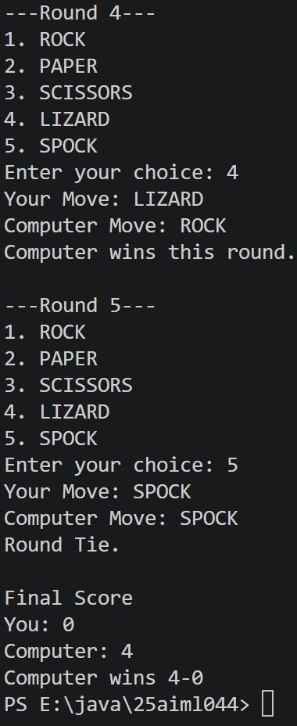

Practical 2
Part A — Practice Programs
- Smart thermostat
CODE:
import java.util.*;

public class Thermostat
{
@SuppressWarnings("unused")
private String location;
private int temperature;
private static int MIN=16;
private static int MAX=30;
private static int activeCount=0;
public Thermostat(String l,int t)
{
if(t>MIN && t<MAX)
{
temperature=t;
}
else
{
temperature=22;
}
activeCount++;

this.location=l;

}
public Thermostat(String l)
{
this(l,22);

}
public void raise()
{
if(temperature<MAX)
{
temperature+=1;
}
else
{
System.out.println("Already at maximum(30)");
}

}
public void lower()
{
if(temperature>MIN)
{
temperature--;
}
else
{
System.out.println("Already at minimum(16)");

}
}
public int getTemperature()
{
return temperature;
}
public static int getActiveCount()
{
return activeCount;
}
public static void main(String[] args)
{

@SuppressWarnings("resource")
Scanner s1 = new Scanner(System.in);
int temp = s1.nextInt();

Thermostat t1 = new Thermostat("room");
Thermostat t2 = new Thermostat("hall", temp);

for(int i=0;i<10;i++)
{
t1.raise();
t2.raise();
System.out.println("Temp from t1 = "+t1.getTemperature()+" Temp from t2 = "+t2.getTemperature());
}
for(int j=0;j<20;j++)
{
t1.lower();
t2.lower();
System.out.println("Temp from t1 = "+t1.getTemperature()+" Temp from t2 = "+t2.getTemperature());

}
System.out.println(Thermostat.getActiveCount());

}

}

OUTPUT:
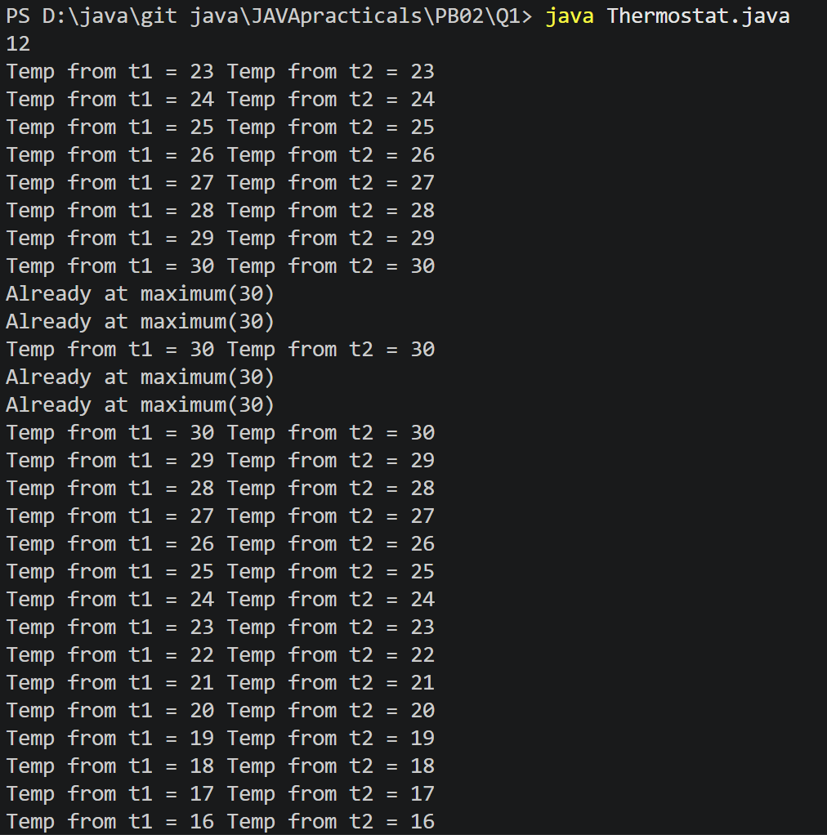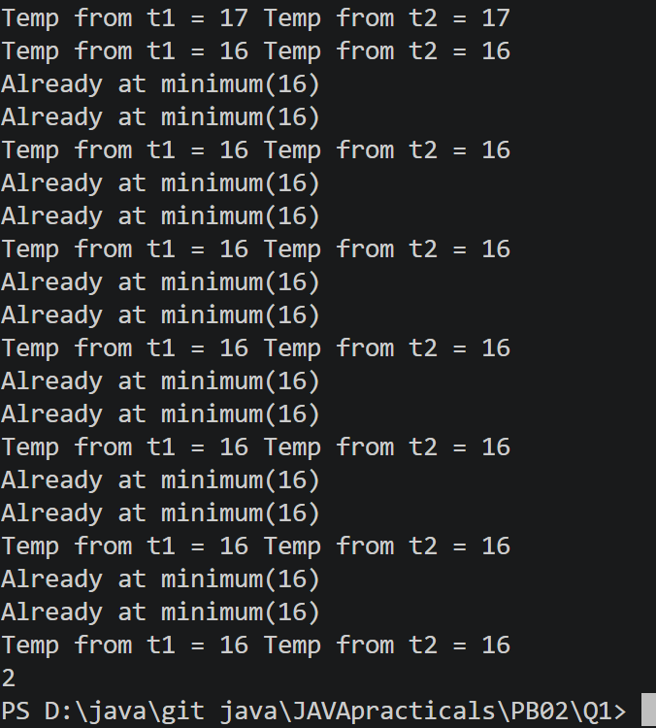

- Cinema show
CODE:
import java.util.*;

public class CinemaShow
{
@SuppressWarnings("unused")
private String title;
private int seatsAvailable;
private final int capacity;
private static int totalBooked=0;
public CinemaShow(String t,int c)
{
title=t;
capacity=c;
seatsAvailable=capacity;
}
public CinemaShow(String t)
{
this(t,100);
}

public boolean book (int n)
{
if(n<=seatsAvailable)
{
seatsAvailable-=n;
totalBooked+=n;
return true;
}
else
{
return false;
}
}
public void cancel(int n)
{
seatsAvailable+=n;
if(seatsAvailable>capacity)
{
seatsAvailable=capacity;
}
}
public int getSeatsAvailable()
{
return seatsAvailable;
}
public static int getTotalBooked()
{
return totalBooked;
}
public static void main(String[] args)
{

Scanner s= new Scanner(System.in);

int cap;
System.out.print("Enter capcaity of cinema:");
cap=s.nextInt();
s.nextLine();

String t;
System.out.print("Enter movie:");
t=s.nextLine();

CinemaShow c= new CinemaShow(t,cap);

while (true){
System.out.println("1. Book ticket");
System.out.println("2. Cancel ticket");
System.out.println("3. Show Available Seats");
System.out.println("4. Exit");
System.out.print("Enter your choice:");
int choice=s.nextInt();
switch ((choice))
{
case 1:
System.out.print("Enter number of tickets:");
int ti=s.nextInt();
boolean result = c.book(ti);
System.out.println("Booking Successful:" + result);
System.out.println("Seats Available:" + c.getSeatsAvailable());
break;

case 2:
System.out.print("Enter number of tickets to cancel:");
int cancel = s.nextInt();

c.cancel(cancel);

System.out.println("Seats Available:" + c.getSeatsAvailable());
break;
case 3:
System.out.println("Seats Available:" + c.getSeatsAvailable());
break;
case 4:

System.out.println("Total Successful Bookings: " + CinemaShow.getTotalBooked());

s.close();
return;
default:
System.out.println("Invalid Choice!");
}

}

}
}

OUTPUT:
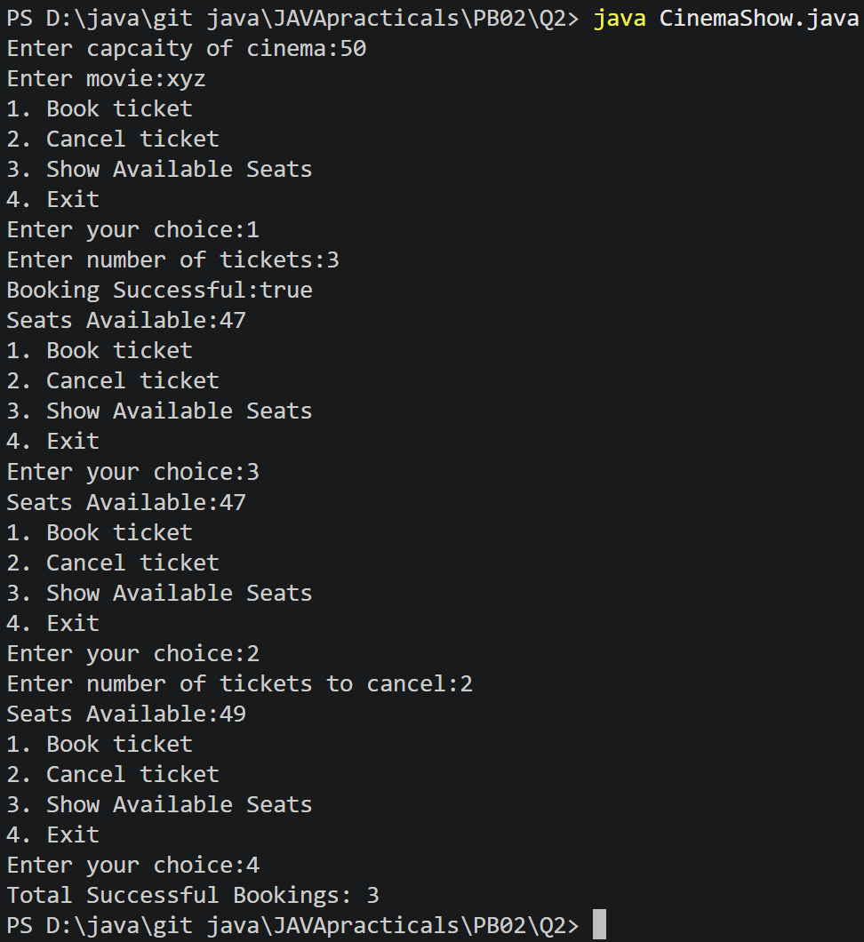

- Parking lot
CODE:
import java.util.*;

public class ParkingLot
{
private int twoWheelers;
private int fourWheelers;
private final int twoCap;
private final int fourCap;
private static long revenue=0;

public ParkingLot(int twoCap, int fourCap)
{
this.twoCap = twoCap;
this.fourCap = fourCap;
twoWheelers = 0;
fourWheelers = 0;
}
public void park(String type)
{
switch (type.toUpperCase())
{
case "TWO":

if(twoWheelers<twoCap)
{
twoWheelers++;
revenue+=20;
}
else
{
System.out.println("FULL");
}

break;
case "FOUR":

if(fourWheelers<fourCap)
{
fourWheelers++;
revenue+=40;
}
else
{
System.out.println("FULL");
}
break;

default:
System.out.println("Invalid type");

}
}
public void leave(String t)
{
switch (t.toUpperCase())
{
case "TWO":

if(twoWheelers>0)
{
twoWheelers--;

}
else
{
System.out.println("Empty");
}

break;
case "FOUR":

if(fourWheelers>0)
{
fourWheelers--;

}
else
{
System.out.println("Empty");
}
break;

default:
System.out.println("Invalid type");

}

}

public int getTwoWheelers()
{
return twoWheelers;
}

public int getFourWheelers()
{
return fourWheelers;
}

public static long getRevenue()
{
return revenue;
}
public static void main(String[] args)
{
Scanner s=new Scanner(System.in);
System.out.print("Enter two-wheeler capacity:");
int two = s.nextInt();

System.out.print("Enter four-wheeler capacity:");
int four = s.nextInt();

ParkingLot p= new ParkingLot(two, four);
while(true)
{
System.out.println("1. Park Vehicle");
System.out.println("2. Leave Vehicle");
System.out.println("3. Show Status");
System.out.println("4. Exit");

System.out.print("Enter choice: ");
int choice = s.nextInt();

switch (choice)
{

case 1:
System.out.print("Enter vehicle type: ");
String type = s.next();
p.park(type);

System.out.println("Two-Wheelers:" + p.getTwoWheelers());
System.out.println("Four-Wheelers:" + p.getFourWheelers());
break;
case 2:
System.out.print("Enter vehicle type: ");
String ty = s.next();
p.leave(ty);
System.out.println("Two-Wheelers:" + p.getTwoWheelers());
System.out.println("Four-Wheelers:" + p.getFourWheelers());
break;
case 3:
System.out.println("Two-Wheelers:" + p.getTwoWheelers());
System.out.println("Four-Wheelers:" + p.getFourWheelers());
System.out.println("Revenue: Rs. " + ParkingLot.getRevenue());
break;

case 4:
System.out.println("Final Occupancy");
System.out.println("Two-Wheelers :" + p.getTwoWheelers());
System.out.println("Four-Wheelers:" + p.getFourWheelers());
System.out.println("Total Revenue:Rs. " + ParkingLot.getRevenue());

s.close();
default:
System.out.println("Invalid Choice");

}
}
}
}

OUTPUT:
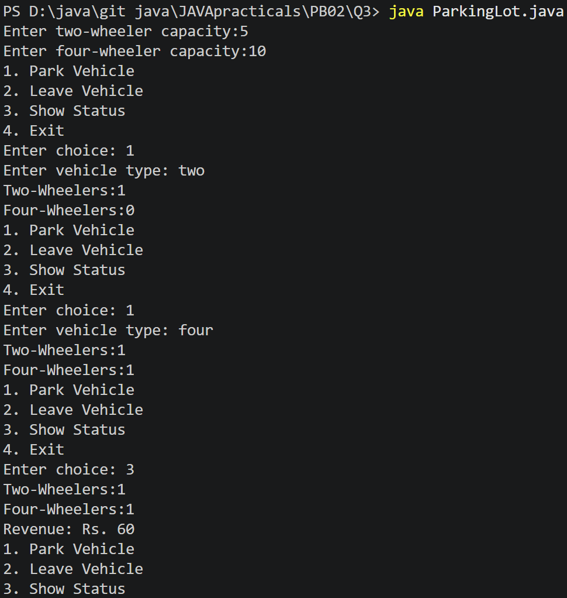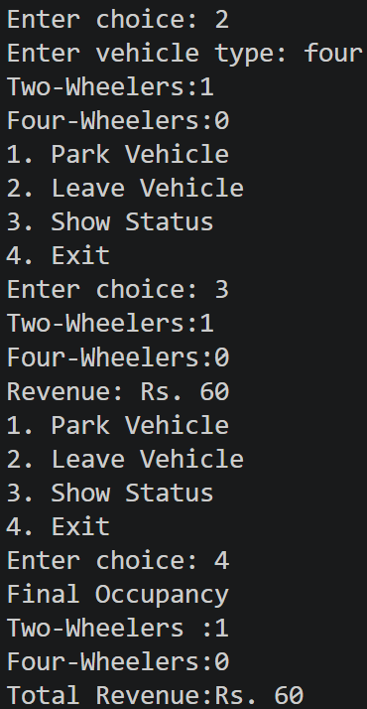

Practical 3

Part A
1) | AIM: Distinct points (Point.java + Driver.java with main)  (a) Create class Point with private int x, y and a constructor.  (b) Override toString() to return “(x, y)”.  (c) Override equals(Object) to be true when both x and y match, and hashCode() to agree (e.g. Objects.hash(x, y)).  (d) In Driver.main: build a Point[] with some repeated coordinates.  (e) Count distinct points: for each point, use equals() to check whether it already appeared earlier; count those that did not.  (f) Print “Distinct: N”. Expected output: 5 points with 2 repeats → “Distinct: 3”
 | Point.java
Code | import java.util.*;  public class Point {  private int x;  private int y;  public Point(int x, int y) {  this.x = x;  this.y = y;  }  @Override  public String toString() {  return "(" + x + "," + y + ")";  }  @Override  public boolean equals(Object o){  if(this==o){  return true;  }  if(!(o instanceof Point)){  return false;  }  Point p= (Point )o;  return this.x==p.x && this.y==p.y;  }  @Override  public int hashCode() {  return Objects.hash(x, y);  }  }
 | Driver.java
Code | public class Driver {  public static void main(String []args){  Point[] point={new Point(1,2),new Point(3,4),new Point(5,6),new Point(3,4)};  int distinctcount = 0;  for (int i = 0; i < point.length; i++) {  boolean seenBefore = false;  for (int j = 0; j < i; j++) {  if (point[i].equals(point[j])) {  seenBefore = true;  break;  }  }  if (!seenBefore) distinctcount++;  }  System.out.println("Distinct:" + distinctcount);  }  }
Output
2) | AIM: Duplicate card check (Card.java + Driver.java)  (a) Create class Card with private String rank, suit and a constructor.  (b) Override toString() to return rank + “ of ” + suit (e.g. “Queen of Hearts”). (c) Override equals()/hashCode() by rank + suit.  (d) In Driver.main: add cards to a Card[] one at a time; before adding each, use equals() to check it against the earlier cards.  (e) Print “Duplicate found: ” the first time a repeat appears. Expected output: a second “Ace of Spades” → “Duplicate found: Ace of Spadescalls, printing the result and seats after each, then print getTotalBooked().  Expected output: booking more than available prints false and leaves seats unchanged; totalBooked equals the successful bookings
 | Card.java
Code | import java.util.Objects;  public class Fraction {  private int num, den;  public Fraction(int num, int den) {  int g = gcd(Math.abs(num), Math.abs(den));  this.num = num / g;  this.den = den / g;  }  private int gcd(int a, int b) {  return b == 0 ? a : gcd(b, a % b);  }  @Override  public String toString() {  return num + "/" + den;  }  @Override  public boolean equals(Object o) {  if (this == o){  return true;  }  if (!(o instanceof Fraction)){  return false;  }  Fraction f = (Fraction) o;  return num == f.num && den == f.den;  }  @Override  public int hashCode() {  return Objects.hash(num, den);  }  }
 | Driver.java
import java.util.ArrayList;
import java.util.List;

public class Driver {
public static void main(String[] args) {
List<Card> cards = new ArrayList<>();
Card[] toAdd = {
new Card("Ace", "Spades"),
new Card("King", "Hearts"),
new Card("Ace", "Spades") // duplicate
};

for (Card c : toAdd) {
boolean isDuplicate = false;
for (Card existing : cards) {
if (existing.equals(c)) {
isDuplicate = true;
break;
}
}
if (isDuplicate) {
System.out.println("Duplicate found: " + c);
break; // stop at first repeat, as spec says "the first time"
}
cards.add(c);
}
}
}

Output | 
Q3) | AIM: Fractions (Fraction.java + Driver.java)  (a) Create class Fraction with private int num, den.  (b) In the constructor, reduce to lowest terms: compute g = gcd(num, den) and divide both by g.  (c) Override toString() to return num + “/” + den.  (d) Override equals()/hashCode() using the reduced num and den.  (e) In Driver.main: create several equivalent fractions (1/2, 2/4, 3/6) and confirm they are all equal and print the same.  Expected output: new Fraction(2,4) prints “1/2” and equals new Fraction(1,2)
 | Fraction.java
Code | import java.util.Objects;  public class Fraction {  private int num, den;  public Fraction(int num, int den) {  int g = gcd(Math.abs(num), Math.abs(den));  this.num = num / g;  this.den = den / g;  }  private int gcd(int a, int b) {  return b == 0 ? a : gcd(b, a % b);  }  @Override  public String toString() {  return num + "/" + den;  }  @Override  public boolean equals(Object o) {  if (this == o){  return true;  }  if (!(o instanceof Fraction)){  return false;  }  Fraction f = (Fraction) o;  return num == f.num && den == f.den;  }  @Override  public int hashCode() {  return Objects.hash(num, den);  }  }
 | Driver.java
Code | public class Driver {  public static void main(String[] args) {  Fraction a = new Fraction(1, 2);  Fraction b = new Fraction(2, 4);  Fraction c = new Fraction(3, 6);  System.out.println(a);  System.out.println(b);  System.out.println(c);  System.out.println(a.equals(b));  System.out.println(b.equals(c));  }  }
Output | 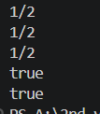

Practical 4

Part A
1) | Password strength (PasswordChecker.java + Driver.java)  - In PasswordChecker, check four rules — length ≥ 8, contains an uppercase letter, contains a digit, contains a special character — using regex (e.g. “.*[A-Z].*”) or String methods.  - Write strength(String pw) that counts how many rules pass and returns “Weak” (0–1), “Medium” (2–3) or “Strong” (4).  - In Driver.main: test several passwords; for each, print which rules passed and the final label.  Expected output: “abc” → Weak; “Abcd1234!” → Strong.
 | PaccwordChecker.java
Code | public class PasswordChecker{  public static boolean hasMinimumLength(String pw){ return pw.length()>=8;  }  public static boolean hasUppercase(String pw){ return pw.matches(".*[A-Z].*");  }  public static boolean hasDigit(String pw){ return pw.matches(".*[0-9].*");  }  public static boolean hasSpecialCharacter(String pw){ return pw.matches(".*[^a-zA-Z0-9].*");  }  public static String strength(String pw){ int count=0; if(hasMinimumLength(pw)){  count++;  }  if(hasUppercase(pw)){ count++;  }  if(hasDigit(pw)){ count++;  }  if(hasSpecialCharacter(pw)){ count++;  }  if(count<=1){ return "Weak";  }  else if(count<=3){ return "Medium";  }

else{
return "Strong";
}
}
}
 | Driver.java
Code | public class Driver {
 | public static void main(String[] args) {
String[] passwords = { "abc",
"abcdefghi", "Abcdefgh", "Abcd1234", "Abcd1234!"
};
 | for (String pw : passwords) {
 | System.out.println("Password: " + pw);
System.out.println("Length >= 8: "
+ PasswordChecker.hasMinimumLength(pw));
System.out.println("Uppercase letter: "
+ PasswordChecker.hasUppercase(pw));
System.out.println("Digit: "
+ PasswordChecker.hasDigit(pw));
System.out.println("Special character: "
+ PasswordChecker.hasSpecialCharacter(pw));
System.out.println("Strength: "
+ PasswordChecker.strength(pw));
System.out.println(" ");
}
}
}

Output | 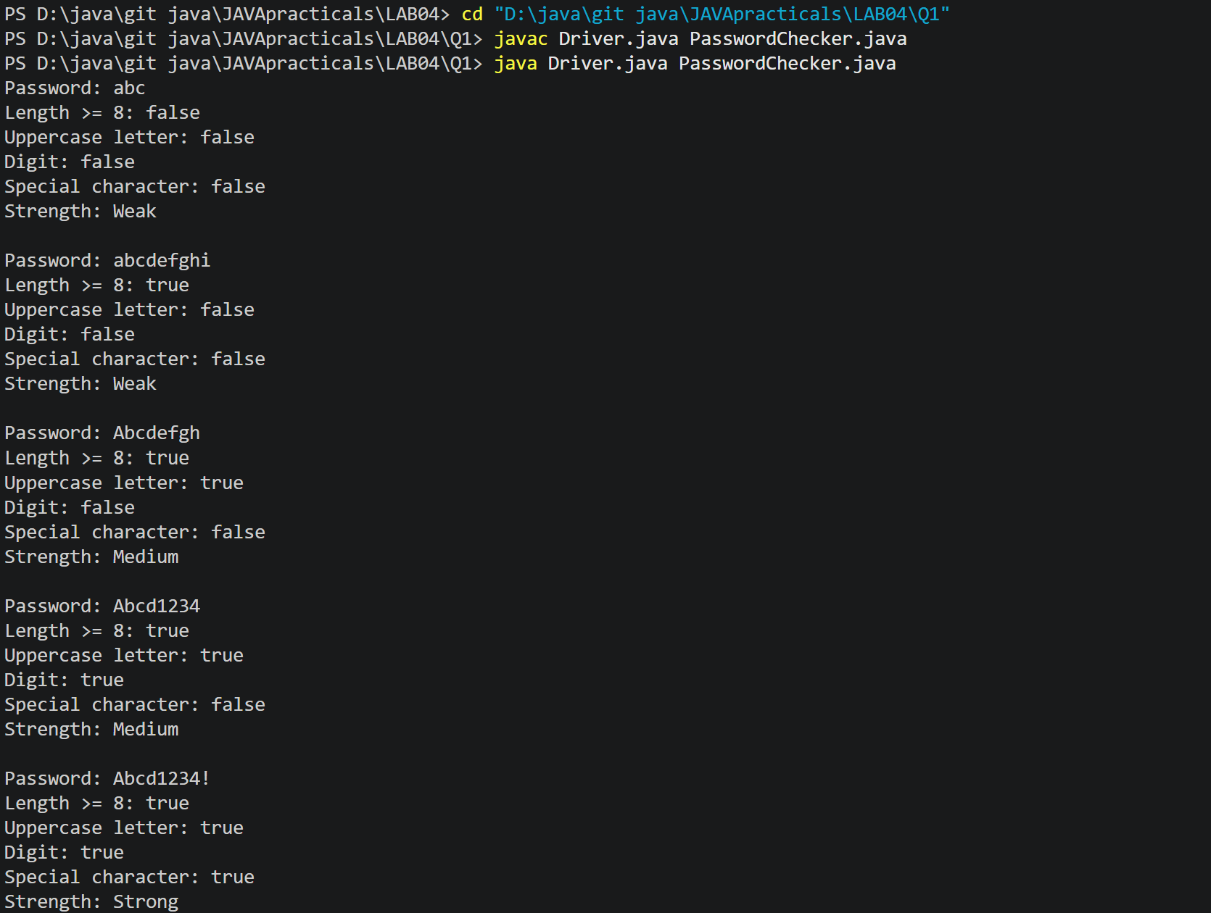
2) | AIM:Chat-log filter (ChatFilter.java + Driver.java)  - In Driver.main, define a String[] of log lines like “10:05 alice Hello there” (include one malformed line with fewer than 3 parts).  - Read a keyword from the user.  - For each line, split into time/user/message with split(“ ”, 3); skip lines that do not have 3 parts.  - If the message contains the keyword (case-insensitive), increment a counter and append “time user: message” to a StringBuilder.  - Print “Matches: N” and the built report.  Expected output: keyword “hello” over 3 lines (1 malformed) → “Matches: 1” and the matching line.
 | ChatFilter .java
Code | public class ChatFilter{  public static String filterLogs(String[] logs, String keyword){ int count=0;  StringBuilder report=new StringBuilder(); for(String line:logs){  String[] parts = line.split(" ",3); if (parts.length<3) {  continue;  }  String time = parts[0];

String user = parts[1]; String message = parts[2];
if(message.toLowerCase().contains(keyword.toLowerCase())){ count++;
report.append(time)
.append(" ")
.append(user)
.append(": ")
.append(message)
.append("\n");
}
}
return "Matches: " + count + "\n" + report;
}
}
 | Driver1.java
import java.util.Scanner;
public class Driver1{
public static void main(String[] args) { String[] logs = {
"10:05 alice Hello there", "10:06 bob How are you?", "10:07 InvalidLine"
};
Scanner sc = new Scanner(System.in); System.out.print("Enter keyword: "); String keyword = sc.nextLine();
String result = ChatFilter.filterLogs(logs, keyword); System.out.println(result);
sc.close();
}
}
Output | 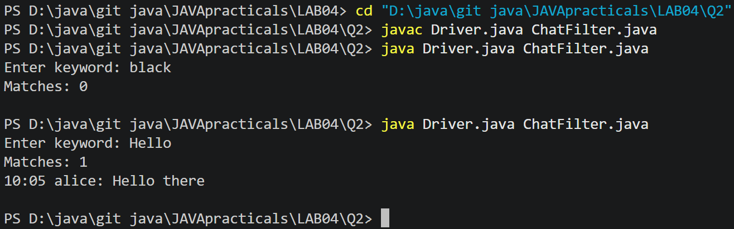
Q3) | AIM: Template filler (TemplateFiller.java + Driver.java)  - In Driver.main, define a template like “Dear {name}, order {id} ships {date}.” and two parallel arrays: names {“name”, “id”} and values {“Riya”, “A07”} (note {date}  is not supplied).  - Compile a Pattern for \{(\w+)\} and get a Matcher on the template.  - Walk the matches with a StringBuilder: for each {placeholder}, look up its value in the names array and replace with the value, or with “[?]” if not found.

(d) Print the filled template.
Expected output: the unsupplied {date} becomes [?].
 | TemplateFiller .java
Code | import java.util.regex.Matcher; import java.util.regex.Pattern; public class TemplateFiller{  public static String fillTemplate(String template, String[] names, String[] values){ Pattern pattern=Pattern.compile("\\{(\\w+)\\}");  Matcher matcher=pattern.matcher(template); StringBuilder result = new StringBuilder(); while (matcher.find()){  String placeholder = matcher.group(1); String replacement = "[?]";  for(int i=0;i<names.length;i++) { if(names[i].equals(placeholder)) {  replacement=values[i]; break;  }  }  matcher.appendReplacement(result, Matcher.quoteReplacement(replacement));  }  matcher.appendTail(result); return result.toString();  }  }
 | Driver2.java
Code | public class Driver2{  public static void main(String[] args){  String template = "Dear {name}, order {id} ships {date}."; String[] names = {"name", "id"};  String[] values = {"Riya", "A07"};  String result = TemplateFiller.fillTemplate( template, names, values);  System.out.println(result);  }  }
Output | 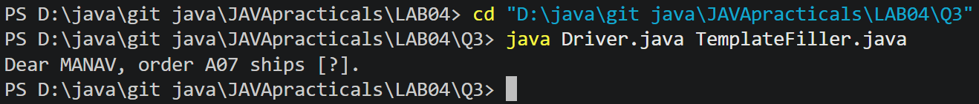

Practical 5
Part A
1) | AIM1. Shape areas: an abstract Shape with abstract area(); subclasses Circle, Rectangle, Triangle. Put a mix in a Shape[] and loop once to print each area and the running total,
Code | import java.util.*;  abstract class Shape{  public abstract float area();  }  class Circle extends Shape{  public float radius;  public Circle(int r){  radius=r;  }  public float area(){  return 3.14f*radius*radius;  }  }  class Rectangle extends Shape{  public float lenght;  public float breadth;  public Rectangle(float l, float b){  lenght = l;  breadth = b;  }  public float area(){  return lenght * breadth;  }  }  class Triangle extends Shape{  public float base;  public float height;  public Triangle(float b, float h){  base= b;  height = h;  }  public float area(){  return 0.5f*base*height;  }  }  public class Main {  public static void main(String[] args) {  Shape[] shapes = {new Circle(5),new Rectangle(4, 6),new Triangle(3, 8),new Circle(3)};  double total_area = 0;  double largest_area = 0;  for (Shape shape : shapes) {  double current_area = shape.area();  System.out.printf("Area: %.2f%n", current_area);  total_area += current_area;  if (current_area > largest_area) {  largest_area = current_area;  }  }  System.out.printf("%nTotal Area: %.2f%n", total_area);  System.out.printf("Largest Area: %.2f%n", largest_area);  }  }
Output | 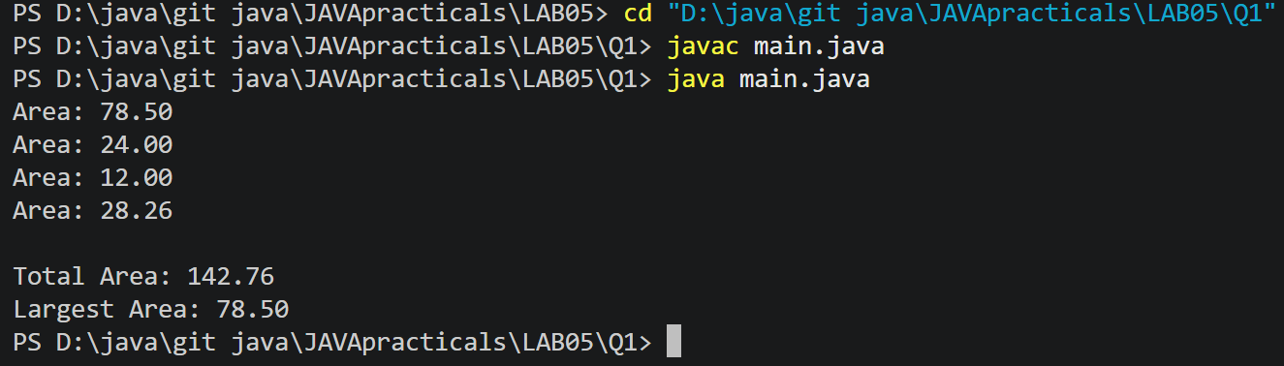
2) | AIM: Payroll: an abstract Employee with abstract monthlySalary(); FullTime (fixed), PartTime (hours × rate) and Intern (stipend), each calling super for the shared name/id. Loop a mixed array to print each salary and the total; use instanceof to add a note only for interns.
Code | import java.util.*;  abstract class Employee {  public String employee_name;  public int employee_id;  public Employee(String name, int id) {  employee_name = name;  employee_id = id;  }  public abstract float monthlySalary();  }  class FullTime extends Employee {  public float salary;  public FullTime(String name, int id) {  super(name, id);  salary = 100000;  }  public float monthlySalary() {  return salary;  }  }  class PartTime extends Employee {  public int hour;  public float rate;  public PartTime(String name, int id, int h, float r) {  super(name, id);  hour = h;  rate = r;  }  public float monthlySalary() {  return rate * hour;  }  }  class Intern extends Employee {  public float salary;  public Intern(String name, int id) {  super(name, id);  salary = 10000;  }  public float monthlySalary() {  return salary;  }  }  public class Main {  public static void main(String[] args) {  Employee[] employees = {  new FullTime("Ansh", 101),  new PartTime("Raj", 102, 80, 300),  new Intern("Jay", 103),  new FullTime("Karan", 104),  new Intern("Dev", 105)  };  float total_salary = 0;  for (Employee employee : employees) {  float salary = employee.monthlySalary();  System.out.println("Employee ID: " + employee.employee_id +", Name:" + employee.employee_name +", Salary: " + salary);  if (employee instanceof Intern) {  System.out.println("Employee is an Intern.");  }  total_salary = total_salary +salary;  }  System.out.println("Total Monthly Payroll:" + total_salary);  }  }
Output | 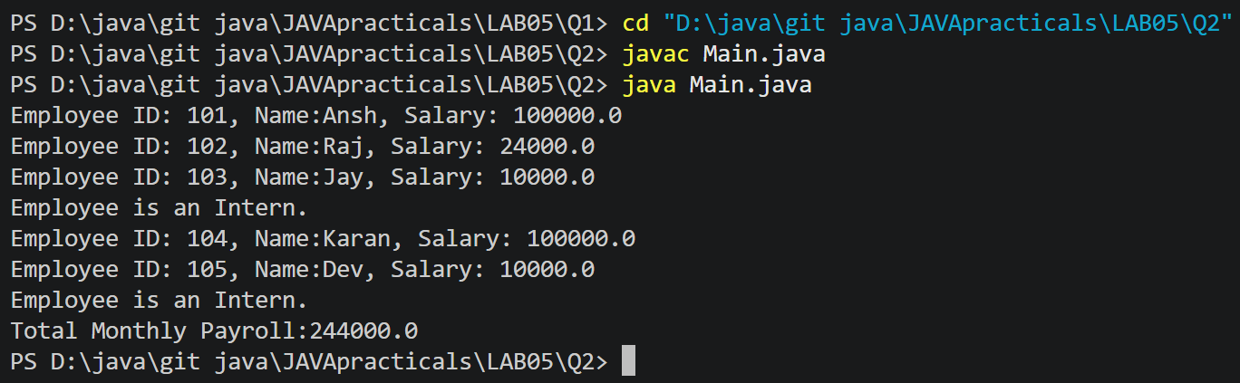
Q3) | AIM: Model a few media types that each compute a late fee differently and total the fees for a returned batch. Design the hierarchy and rules yourself
Code | abstract class Media {  public String media_name;  public int media_id;  public int late_days;  public Media(String n, int i, int d) {  media_name = n;  media_id = i;  late_days = d;  }  public abstract float late_fee();  }  class Book extends Media {  public Book(String name, int id, int days) {  super(name, id, days);  }  public float late_fee() {  return late_days * 2;  }  }  class DVD extends Media {  public DVD(String name, int id, int days) {  super(name, id, days);  }  public float late_fee() {  return late_days * 5;  }  }  class Game extends Media {  public Game(String name, int id, int days) {  super(name, id, days);  }  public float late_fee() {  return late_days*8;  }  }  public class Main {  public static void main(String[] args) {  Media[] returned_media = {new Book("Java Programming", 101, 3),new DVD("Avengers", 102, 2),new Game("Minecraft", 103, 5),  new Book("Data Structures", 104, 4),new DVD("Interstellar", 105, 1)};  float total_fee=0;  for (Media media:returned_media) {  float fee = media.late_fee();  System.out.println("Media ID:" + media.media_id +",Name:" + media.media_name +",Late Days:" + media.late_days +",Late Fee:Rs." + fee);  total_fee = total_fee + fee;  }  System.out.println("Total Late Fees:Rs." + total_fee);  }  }
Output | 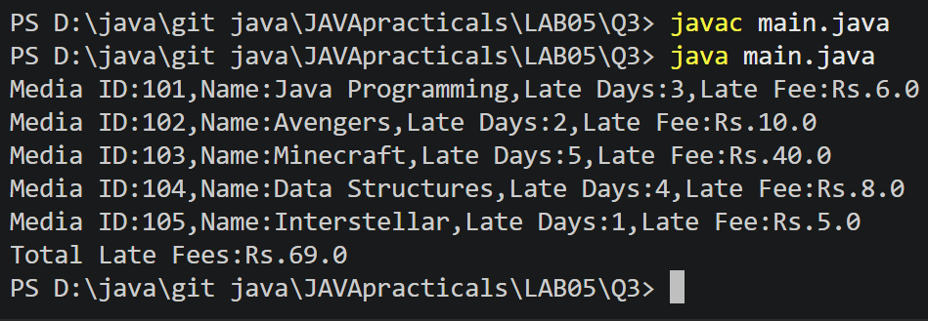

Practical 6

Part A
1) | Remote control: an interface Switchable with on()/off() and a default toggle(); Fan and Light implement it. Loop over a Switchable[] toggling each. Then add a functional interface that decides, given a device and an hour, whether it may switch on, and supply it once as an anonymous class and once as a lambda.
Code | interface Switchable  {  void on();  void off();  default void toggle()  {  on();  }  }  class Fan implements Switchable  {  public void on() {  System.out.println("Fan is ON");  }  public void off() {  System.out.println("Fan is OFF");  }  }  class Light implements Switchable  {  public void on() {  System.out.println("Light is ON");  }  public void off() {  System.out.println("Light is OFF");  }  }  @FunctionalInterface  interface SwitchPermission  {  boolean maySwitchOn(Switchable device, int hour);  }  public class RemoteControl  {  public static void main(String[] args)  {  Switchable[] devices =  {  new Fan(),  new Light()  };  System.out.println("Toggling Devices:");  for (Switchable device : devices)  {  device.toggle();  }  SwitchPermission permission1 = new SwitchPermission() {  public boolean maySwitchOn(Switchable device, int hour) {  return hour >= 6 && hour <= 22;  }  };  SwitchPermission permission2 =  (device, hour) -> hour >= 6 && hour <= 22;  int hour = 10;  System.out.println("\nAnonymous Class:");  System.out.println(  permission1.maySwitchOn(devices[0], hour)  );  System.out.println("\nLambda:");  System.out.println(  permission2.maySwitchOn(devices[1], hour)  );  }  }
Output | 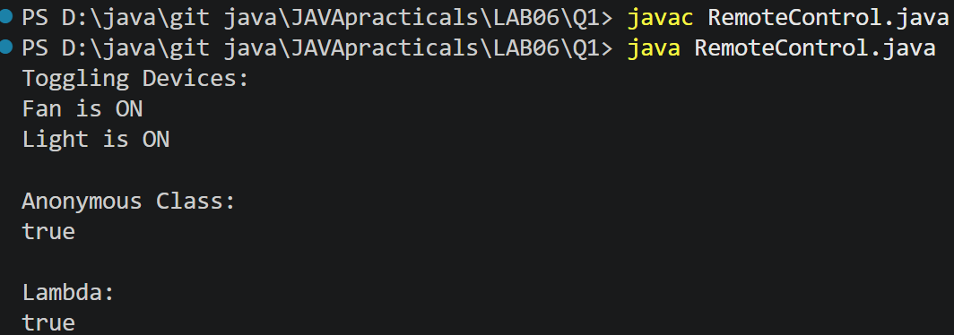
2) | Notification senders: a functional interface Notifier with send(String); make email and SMS senders as lambdas, hold them in an array, and broadcast one message through all. Add a marker interface Urgent and send twice for senders marked urgent.
Code | @FunctionalInterface  interface Notifier {  void send(String message);  }  interface Urgent {  }  class UrgentNotifier implements Notifier, Urgent {  private Notifier notifier;  UrgentNotifier(Notifier notifier) {  this.notifier = notifier;  }  public void send(String message) {  notifier.send(message);  }  }  public class NotificationSender {  public static void main(String[] args) {  Notifier email = message ->  System.out.println("Email: " + message);  Notifier sms = message ->  System.out.println("SMS: " + message);  Notifier urgentEmail = new UrgentNotifier(email);  Notifier[] senders = {  urgentEmail,  sms  };  String message = "Exam tomorrow at 10 AM";  for (Notifier sender : senders) {  sender.send(message);  if (sender instanceof Urgent) {  sender.send(message);  }  }  }  }
Output | 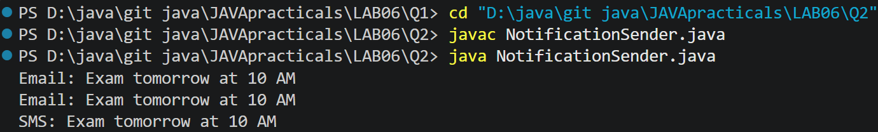
Q3) | (For Advanced Learners – home) Build a small discount engine where each rule is a lambda the user picks at runtime and applies to a list of prices; organise it into packages and ship it as a runnable JAR.
Code
  DiscountRule | package discount;  @FunctionalInterface  public interface DiscountRule {  double apply(double price);  }
  Main.java | import discount.DiscountRule;  import java.util.*;  public class Main {  public static void main(String[] args) {  List<Double> prices = Arrays.asList(  1000.0,  2000.0,  3000.0,  5000.0  );  Scanner sc = new Scanner(System.in);  System.out.println("Discount Engine");  System.out.println("1. 10% Discount");  System.out.println("2. 20% Discount");  System.out.println("3. Flat Rs.500 Discount");  System.out.print("Choose discount: ");  int choice = sc.nextInt();  DiscountRule rule;  switch (choice) {  case 1:  rule = price -> price * 0.90;  break;  case 2:  rule = price -> price * 0.80;  break;  case 3:  rule = price -> price - 500;  break;  default:  System.out.println("Invalid choice");  sc.close();  return;  }  System.out.println("\nOriginal Price -> Final Price");  for (double price : prices) {  double finalPrice = rule.apply(price);  if (finalPrice < 0) {  finalPrice = 0;  }  System.out.println(  "Rs." + price + " -> Rs." + finalPrice  );  }  sc.close();  }  }
Output | 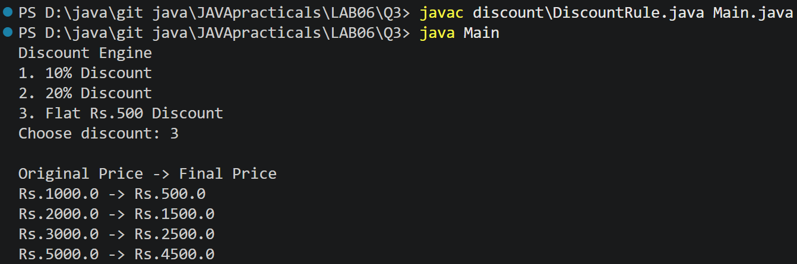

PRACTICAL - 07
Part A — Practice Programs (Hour 1)

PROBLEM1 | 1. Form validator: define @NotBlank and @MaxLength(int) for fields and annotate a SignupForm. Write a checker that uses reflection to read each field’s annotations and returns the list of validation errors for a given object.
CODE | import java.lang.annotation.*;  import java.lang.reflect.Field;  import java.util.*;  @Retention(RetentionPolicy.RUNTIME)  @Target(ElementType.FIELD)  @interface NotBlank {  }  @Retention(RetentionPolicy.RUNTIME)  @Target(ElementType.FIELD)  @interface MaxLength {  int value();  }  class SignupForm {  @NotBlank  @MaxLength(10)  String username;  @NotBlank  @MaxLength(20)  String email;  SignupForm(String username, String email) {  this.username = username;  this.email = email;  }  }  public class Main {  public static void main(String[] args) throws Exception {  SignupForm form = new SignupForm("", "abcdefghijklmnop@gmail.com");  List<String> errors = new ArrayList<>();  for (Field field : form.getClass().getDeclaredFields()) {  field.setAccessible(true);  String value = (String) field.get(form);  // Check NotBlank  if (field.isAnnotationPresent(NotBlank.class)) {  if (value == null || value.trim().isEmpty()) {  errors.add(field.getName() + " cannot be blank");  }  }  // Check MaxLength  if (field.isAnnotationPresent(MaxLength.class)) {  MaxLength max = field.getAnnotation(MaxLength.class);  if (value != null && value.length() > max.value()) {  errors.add(field.getName()  + " is too long. Maximum "  + max.value() + " characters allowed");  }  }  }  if (errors.isEmpty()) {  System.out.println("Form is valid");  } else {  for (String error : errors) {  System.out.println(error);  }  }  }  }
OUTPUT | 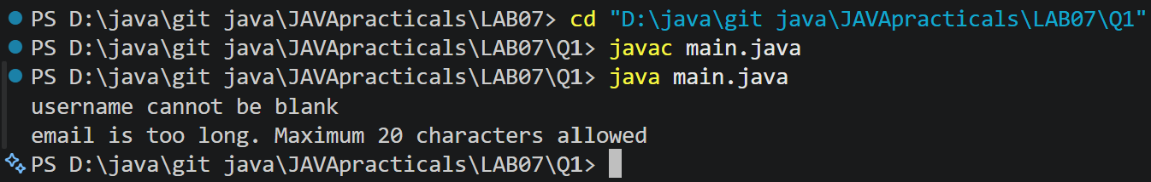
PROBLEM2 | 2. Mini test runner: define a @Run annotation and mark some no-arg methods of a class with it. Use reflection to find and invoke only the @Run methods and report how many ran — the idea behind how JUnit finds @Test methods.
CODE | import java.lang.annotation.*;  import java.lang.reflect.Method;  @Retention(RetentionPolicy.RUNTIME)  @Target(ElementType.METHOD)  @interface Run {  }  class MyTests {  @Run  public void test1() {  System.out.println("Test 1 executed");  }  @Run  public void test2() {  System.out.println("Test 2 executed");  }  public void normalMethod() {  System.out.println("Normal method");  }  }  public class Mini {  public static void main(String[] args) throws Exception {  MyTests obj = new MyTests();  int count = 0;  Method[] methods = obj.getClass().getDeclaredMethods();  for (Method method : methods) {  if (method.isAnnotationPresent(Run.class)  && method.getParameterCount() == 0) {  method.invoke(obj);  count++;  }  }  System.out.println("Total methods executed: " + count);  }  }
OUTPUT | 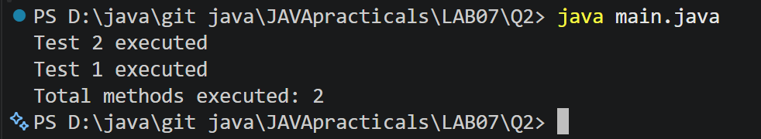
PROBLEM3 | 3. (For Advanced Learners – home) Define a @Column(name) annotation and, by reflection, populate an object’s fields from a header row and a data row by matching column names; decide how to handle a missing column.
CODE | import java.lang.annotation.*;  import java.lang.reflect.Field;  @Retention(RetentionPolicy.RUNTIME)  @Target(ElementType.FIELD)  @interface Column {  String name();  }  class Student {  @Column(name = "id")  String id;  @Column(name = "name")  String name;  @Column(name = "email")  String email;  }  public class Columns {  public static void main(String[] args) throws Exception {  String[] headers = {"id", "name", "email"};  String[] data = {"101", "Om", "om@gmail.com"};  Student student = new Student();  Field[] fields = student.getClass().getDeclaredFields();  for (Field field : fields) {  if (field.isAnnotationPresent(Column.class)) {  Column column = field.getAnnotation(Column.class);  for (int i = 0; i < headers.length; i++) {  if (headers[i].equals(column.name())) {  field.setAccessible(true);  field.set(student, data[i]);  break;  }  }  }  }  System.out.println("ID: " + student.id);  System.out.println("Name: " + student.name);  System.out.println("Email: " + student.email);  }  }
OUTPUT | 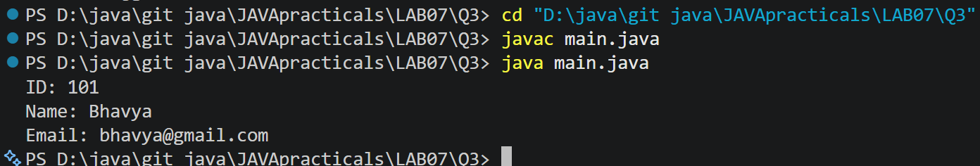

PRACTICAL - 08
Part A — Practice Programs (Hour 1)

PROBLEM1 | 1. Guarded calculator: read two numbers and an operator; throw a custom  DivideByZeroException and catch invalid-number input separately, printing a clear  message each time; loop until a valid calculation succeeds and use finally to log each  attempt.
CODE | import java.util.Scanner;  public class Calculator {  public static void main(String[] args) {  Scanner sc = new Scanner(System.in);  try {  System.out.print("Enter first number: ");  double num1 = sc.nextDouble();  System.out.print("Enter second number: ");  double num2 = sc.nextDouble();  if (num1 < 0 || num2 < 0) {  throw new InvalidNumberException("Negative numbers are not allowed!");  }  if(num1==0 || num2==0){  throw new InvalidNumberException("Multiplication By Zero is not allowed!");  }  System.out.print("Enter operator (+, -, *, /): ");  char op = sc.next().charAt(0);  System.out.println("You entered: " + num1 + " " + op + " " + num2);  double result = 0;  if (op == '+') {  result = num1 + num2;  } else if (op == '-') {  result = num1 - num2;  } else if (op == '*') {  result = num1 * num2;  } else if (op == '/') {  if (num2 == 0) {  throw new DivideByZeroException("Cannot divide by zero!");  }  result = num1 / num2;  } else {  throw new InvalidNumberException("Invalid operator entered!");  }  System.out.println(num1 + " " + op + " " + num2 + " = " + result);  } catch (DivideByZeroException e) {  System.out.println("Error: " + e.getMessage());  } catch (InvalidNumberException e) {  System.out.println("Error: " + e.getMessage());  } catch (Exception e) {  System.out.println("Unexpected error: " + e.getMessage());  } finally {  System.out.println("Exiting the program.");  sc.close();  }  }  }  class DivideByZeroException extends Exception {  public DivideByZeroException(String message) {  super(message);  }  }  class InvalidNumberException extends Exception {  public InvalidNumberException(String message) {  super(message);  }  }
OUTPUT | 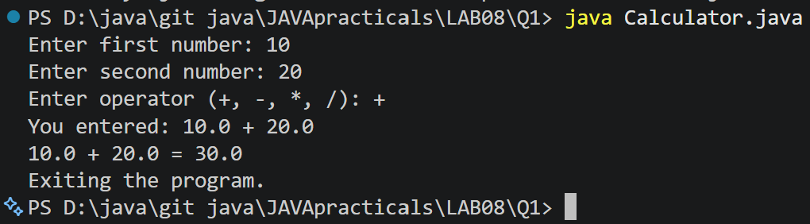
PROBLEM2 | 2. Stock issue: a Warehouse where issue(item, qty) throws a custom checked  OutOfStockException carrying the shortfall, and InvalidQuantityException for qty ≤ 0.  Process a list of requests, catching and reporting each failure without stopping the run.
CODE | import java.util.Scanner;  class outofstockexception extends Exception {  private int shortage;  public outofstockexception(int shortage) {  super("out of stock! shortage: " + shortage);  this.shortage = shortage;  }  public int getshortage() {  return shortage;  }  }  class invalidquantityexception extends Exception {  public invalidquantityexception() {  super("invalid quantity! must be greater than 0.");  }  }  class store {  private int stock;  public store(int stock) {  this.stock = stock;  }  public void issue(String item, int qty)  throws outofstockexception, invalidquantityexception {  if (qty <= 0) {  throw new invalidquantityexception();  }  if (qty > stock) {  int shortage = qty - stock;  throw new outofstockexception(shortage);  }  stock -= qty;  System.out.println("issued: " + qty + " " + item);  System.out.println("left in stock: " + stock);  }  }  public class storemanagement {  public static void main(String[] args) {  Scanner sc = new Scanner(System.in);  System.out.print("enter starting stock: ");  int stock = sc.nextInt();  store s = new store(stock);  System.out.print("enter number of requests: ");  int requests = sc.nextInt();  sc.nextLine();  for (int i = 1; i <= requests; i++) {  System.out.println("\nrequest " + i);  System.out.print("enter item name: ");  String item = sc.nextLine();  System.out.print("enter quantity: ");  int qty = sc.nextInt();  sc.nextLine();  try {  s.issue(item, qty);  } catch (outofstockexception e) {  System.out.println("error: " + e.getMessage());  } catch (invalidquantityexception e) {  System.out.println("error: " + e.getMessage());  }  }  sc.close();  }  }
OUTPUT | 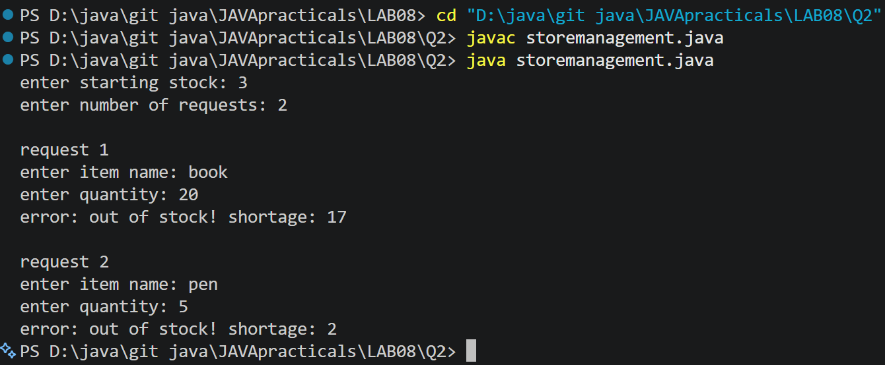
PROBLEM3 | 3. (For Advanced Learners – home) Create an AutoCloseable resource and use try-with-  resources to prove it always closes — even when an exception is thrown inside the block  — and that the original error is the one reported. Decide what to model as the resource.
CODE | class MyResource implements AutoCloseable {  void doWork() {  System.out.println("Resource is doing some work...");  throw new RuntimeException("Original error occurred");  }  @Override  public void close() {  System.out.println("Resource is closed");  throw new RuntimeException("Error while closing resource");  }  }  public class Main {  public static void main(String[] args) {  try (MyResource resource = new MyResource()) {  System.out.println("Resource is opened");  resource.doWork();  } catch (Exception e) {  System.out.println("Main error: " + e.getMessage());  for (Throwable error : e.getSuppressed()) {  System.out.println("Suppressed error: " + error.getMessage());  }  }  }  }
OUTPUT | 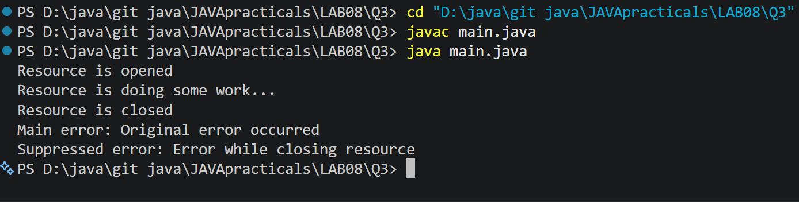

CEUE203 : Object Oriented Programming 25AIML044

PRACTICAL – 9
AIM:
1. Counter race: several threads each increment a shared counter many times. Run it without synchronization to watch the total come out too low, then make the increment synchronized and confirm it is exactly right every run.
.CODE:
import java.util.Scanner;

class Counter {
int count = 0;

// Unsynchronized increment void increment() {
count++;
}

// Synchronized increment
synchronized void synchronizedIncrement() { count++;
}
}

class MyThread extends Thread { Counter counter;
int increments;
boolean useSynchronization;

MyThread(Counter counter, int increments, boolean useSynchronization) { this.counter = counter;
this.increments = increments;
this.useSynchronization = useSynchronization;
}

public void run() {
for (int i = 0; i < increments; i++) {

if (useSynchronization) {
counter.synchronizedIncrement();
} else {
counter.increment();
}

ccCSPIT - AIML | 1

CEUE203 : Object Oriented Programming 25AIML044

public class CounterRace {

public static void main(String[] args) throws Exception { Scanner sc = new Scanner(System.in);
System.out.print("Enter number of threads: "); int numberOfThreads = sc.nextInt();

System.out.print("Enter number of increments per thread: "); int increments = sc.nextInt();

System.out.print("Use synchronization? (yes/no): "); String choice = sc.next();

boolean useSynchronization = choice.equalsIgnoreCase("yes"); Counter counter = new Counter();
MyThread[] threads = new MyThread[numberOfThreads];

// Creating threads
for (int i = 0; i < numberOfThreads; i++) { threads[i] = new MyThread(
counter,
increments,
useSynchronization);
}

// Starting threads
for (int i = 0; i < numberOfThreads; i++) { threads[i].start();
}

// Waiting for all threads to finish
for (int i = 0; i < numberOfThreads; i++) { threads[i].join();
}
int expectedValue = numberOfThreads * increments; System.out.println("\n----- Result ");
System.out.println("Number of Threads: " + numberOfThreads); System.out.println("Increments per Thread: " + increments);
System.out.println("Expected Counter Value: " + expectedValue); System.out.println("Actual Counter Value: " + counter.count);
ccCSPIT - AIML | 2

CEUE203 : Object Oriented Programming 25AIML044

if (counter.count == expectedValue) {
System.out.println("Result is correct.");
} else {
System.out.println("Race condition occurred.");
}

sc.close();
}
}

OUTPUT SCREENSHOT:
With synchronization :

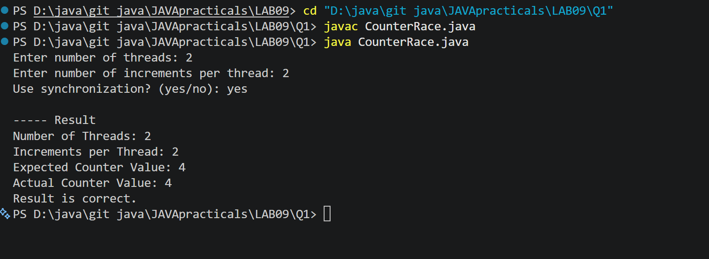
Without synchronization :

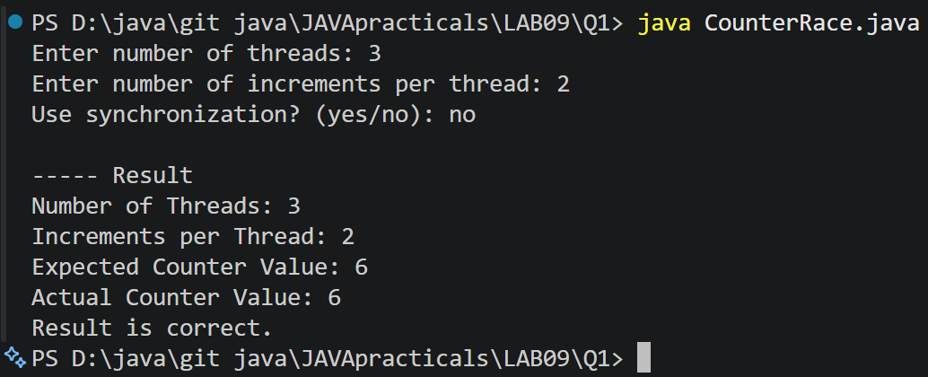
LEARNING OUTCOME:
- How to create and use multiple threads in Java.
- How threads share common data.
- What a race condition is.
ccCSPIT - AIML | 3

CEUE203 : Object Oriented Programming 25AIML044

- Why race conditions can produce incorrect results.
- How the synchronized keyword prevents simultaneous access to shared data.
- How start() starts a thread and join() waits for a thread to finish.
- How synchronization helps maintain data consistency in multithreaded programs.
2. Seat booking race: a shared seatsLeft of 5 with about 10 threads each trying to book one seat. Without synchronization show that more than 5 can succeed (oversell); with a synchronized book() exactly 5 do..
CODE:
import java.util.Scanner; class SeatBooking {
int seatsLeft;
int successfulBookings = 0;

SeatBooking(int seats) { seatsLeft = seats;
}

// Booking without synchronization void book(String userName) {

if (seatsLeft > 0) {

// Small delay makes the race condition easier to observe try {
Thread.sleep(10);
} catch (InterruptedException e) { System.out.println(e);
}

seatsLeft--;
successfulBookings++;

System.out.println(userName + " booked a seat.");
} else {
System.out.println(userName + " could not book a seat.");
}
}

// Booking with synchronization
synchronized void synchronizedBook(String userName) { if (seatsLeft > 0) {
ccCSPIT - AIML | 4

CEUE203 : Object Oriented Programming 25AIML044

try {
Thread.sleep(10);
} catch (InterruptedException e) { System.out.println(e);
}

seatsLeft--;
successfulBookings++;

System.out.println(userName + " booked a seat.");
} else {
System.out.println(userName + " could not book a seat.");
}
}
}
class BookingThread extends Thread { SeatBooking booking;
String userName;
boolean useSynchronization;

BookingThread(
SeatBooking booking, String userName,
boolean useSynchronization) { this.booking = booking;
this.userName = userName;
this.useSynchronization = useSynchronization;
}

public void run() {

if (useSynchronization) {
booking.synchronizedBook(userName);
} else {
booking.book(userName);
}
}
}

public class SeatBookingRace {

public static void main(String[] args) throws Exception { Scanner sc = new Scanner(System.in);
ccCSPIT - AIML | 5

CEUE203 : Object Oriented Programming 25AIML044

System.out.print("Enter number of seats: "); int totalSeats = sc.nextInt();

System.out.print("Enter number of users: "); int numberOfUsers = sc.nextInt();

System.out.print("Use synchronization? (yes/no): "); String choice = sc.next();

boolean useSynchronization = choice.equalsIgnoreCase("yes"); SeatBooking booking = new SeatBooking(totalSeats);
BookingThread[] users = new BookingThread[numberOfUsers];

// Creating booking threads
for (int i = 0; i < numberOfUsers; i++) { String userName = "User-" + (i + 1);
users[i] = new BookingThread( booking,
userName,
useSynchronization);
}

// Starting all users
for (int i = 0; i < numberOfUsers; i++) { users[i].start();
}

// Waiting for all users to finish
for (int i = 0; i < numberOfUsers; i++) { users[i].join();
}

System.out.println("\n----- Booking Result ");

System.out.println("Total Seats: "
+ totalSeats);

System.out.println("Total Users: "
+ numberOfUsers);

System.out.println("Successful Bookings: "
+ booking.successfulBookings); System.out.println("Seats Left: "
ccCSPIT - AIML | 6

CEUE203 : Object Oriented Programming 25AIML044
+ booking.seatsLeft);

if (booking.successfulBookings > totalSeats) {
System.out.println("Overselling occurred!");
} else {
System.out.println("No overselling occurred.");
}

sc.close();
}
}

OUTPUT SCREENSHOT:

With synchronization :

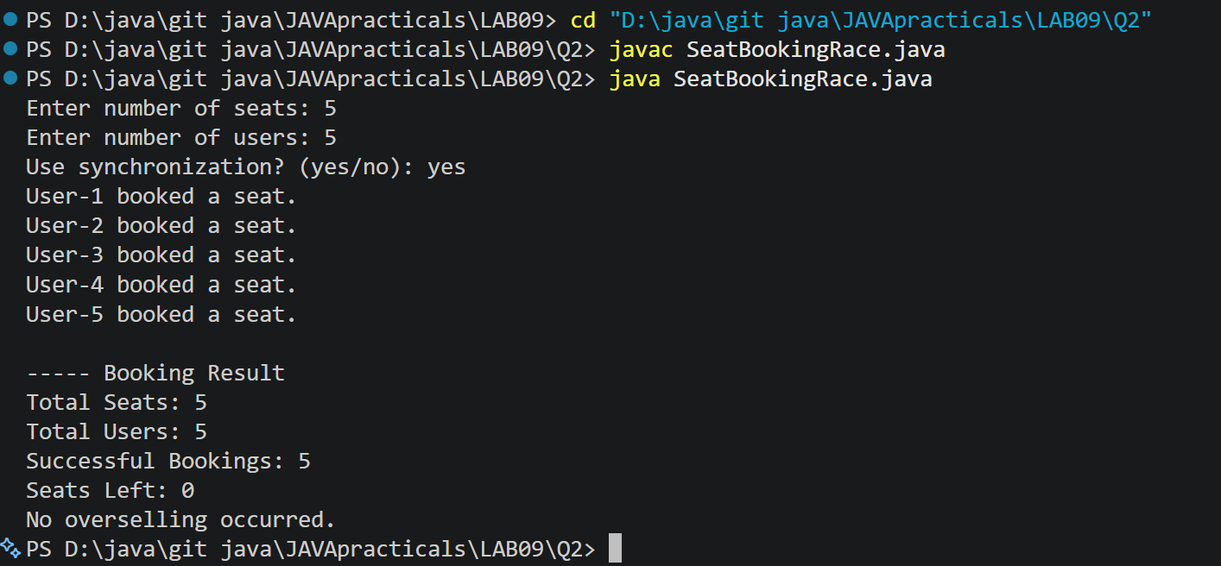

Without synchronization :

ccCSPIT - AIML 7

CEUE203 : Object Oriented Programming 25AIML044

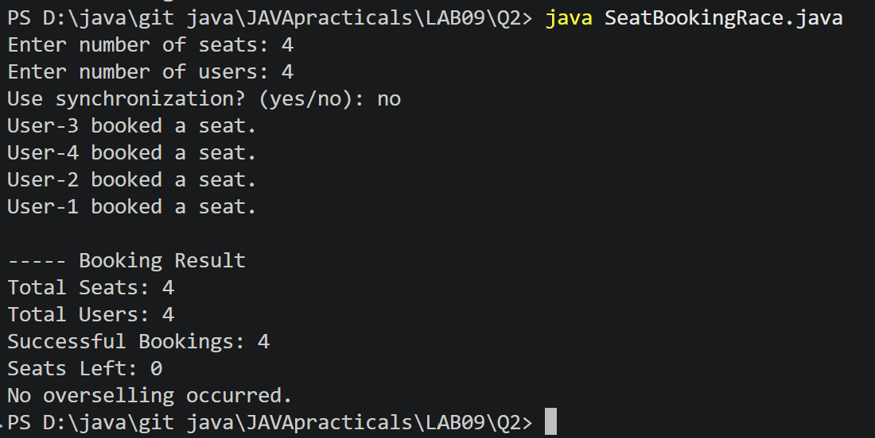
LEARNING OUTCOME:
- How multiple threads can access a shared resource.
- What a race condition is in a real-world booking system.
- How race conditions can cause overselling.
- Why checking and modifying shared data must be synchronized.
- How the synchronized keyword provides thread safety.
- How multiple users can be simulated using Java threads.
- How start() is used to run threads and join() is used to wait for them.
- How synchronization ensures that the number of successful bookings never exceeds the available seats.
ccCSPIT - AIML | 8

CEUE203 : Object Oriented Programming 25AIML044

3. (For Advanced Learners – home) Split a large array of numbers across several threads that add into one shared total, show the wrong result, then fix it two ways and compare;
decide how to measure the difference. CODE:
import java.util.Scanner; class SharedTotal {
long total = 0;

// Method 1: Without synchronization void add(long value) {
total += value;
}

// Method 2: Using synchronized method
synchronized void synchronizedAdd(long value) { total += value;
}
}

class SumThread extends Thread { int[] numbers;
ccCSPIT - AIML | 9

CEUE203 : Object Oriented Programming 25AIML044

int start; int end;
SharedTotal sharedTotal; int method;

SumThread(int[] numbers, int start, int end,
SharedTotal sharedTotal, int method) {

this.numbers = numbers; this.start = start;
this.end = end;
this.sharedTotal = sharedTotal; this.method = method;
}

public void run() {
for (int i = start; i < end; i++) { if (method == 1) {
// No synchronization
sharedTotal.add(numbers[i]);

} else {
// Synchronized method
sharedTotal.synchronizedAdd(numbers[i]);
}
}
}
}

public class ParallelArraySum {

public static void main(String[] args) throws Exception { Scanner sc = new Scanner(System.in);
System.out.print("Enter array size: "); int size = sc.nextInt();

System.out.print("Enter number of threads: "); int numberOfThreads = sc.nextInt();

System.out.print("Enter maximum value of array elements: "); int maxValue = sc.nextInt();

// Creating array
int[] numbers = new int[size];
ccCSPIT - AIML | 10

CEUE203 : Object Oriented Programming 25AIML044

// Filling array with values
for (int i = 0; i < size; i++) {
numbers[i] = (i % maxValue) + 1;
}

// Calculate correct answer using single thread long correctTotal = 0;

for (int number : numbers) { correctTotal += number;
}

System.out.println("\nCorrect Total: " + correctTotal);

// Run both methods
for (int method = 1; method <= 2; method++) {

SharedTotal sharedTotal = new SharedTotal();

SumThread[] threads = new SumThread[numberOfThreads]; int part = size / numberOfThreads;
long startTime = System.nanoTime();

// Creating threads
for (int i = 0; i < numberOfThreads; i++) { int start = i * part;
int end;

if (i == numberOfThreads - 1) { end = size;
} else {
end = start + part;
}

threads[i] = new SumThread( numbers,
start, end,
sharedTotal, method);
}

// Starting threads
ccCSPIT - AIML | 11

CEUE203 : Object Oriented Programming 25AIML044

for (int i = 0; i < numberOfThreads; i++) { threads[i].start();
}

// Waiting for threads
for (int i = 0; i < numberOfThreads; i++) { threads[i].join();
}

long endTime = System.nanoTime();

long timeTaken = endTime - startTime;

System.out.println("\n----- Method " + method + " ");

if (method == 1) {
System.out.println(
"Method: Without Synchronization");
} else {
System.out.println(
"Method: Synchronized Method");
}

System.out.println(
"Calculated Total: "
+ sharedTotal.total);

System.out.println(
"Time Taken: "
+ timeTaken
+ " nanoseconds");

if (sharedTotal.total == correctTotal) {
System.out.println("Result is CORRECT.");
} else {
System.out.println("Result is WRONG.");
}
}

sc.close();
}
}

OUTPUT SCREENSHOT:
ccCSPIT - AIML | 12

CEUE203 : Object Oriented Programming 25AIML044

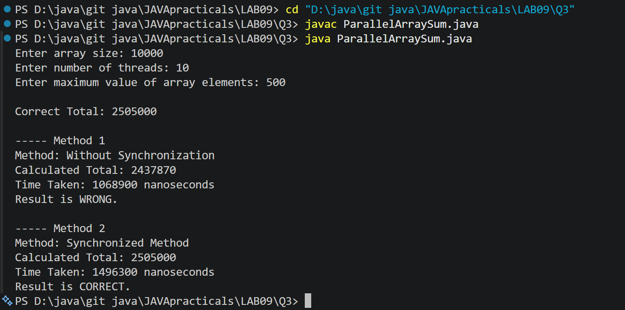

PRACTICAL - 10
Part A — Practice Programs (Hour 1)

PROBLEM1 | 1. Thread-pool runner: with a fixed pool of 3 (ExecutorService), submit about 10 Runnable  tasks that print their id and sleep briefly; shut down and await completion, observing the  few threads being reused.
CODE | import java.util.concurrent.ExecutorService;  import java.util.concurrent.Executors;  import java.util.concurrent.TimeUnit;  public class ThreadPoolRunner {  public static void main(String[] args) {  ExecutorService executor = Executors.newFixedThreadPool(3);  for (int i = 1; i <= 10; i++) {  final int taskId = i;  executor.execute(() -> {  System.out.println(  "Task " + taskId + " executed by "  + Thread.currentThread().getName()  );  try {  Thread.sleep(500);  } catch (InterruptedException e) {  Thread.currentThread().interrupt();  }  });  }  executor.shutdown();  try {  if (!executor.awaitTermination(30, TimeUnit.SECONDS)) {  executor.shutdownNow();  }  } catch (InterruptedException e) {  executor.shutdownNow();  Thread.currentThread().interrupt();  }  System.out.println("All tasks completed.");  }  }
OUTPUT | 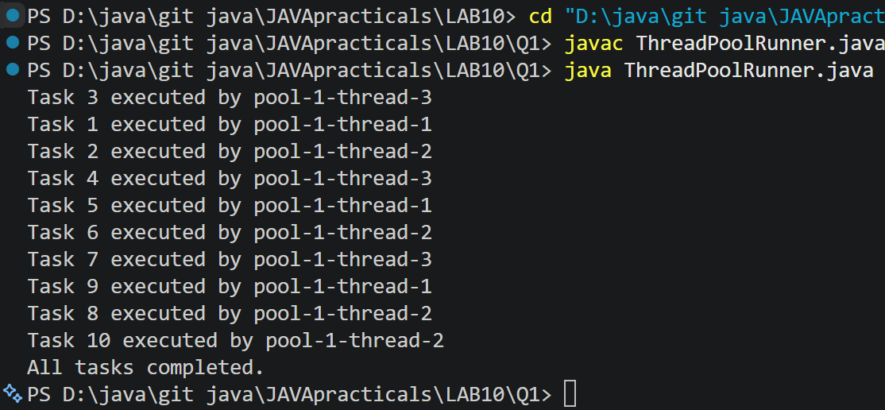
PROBLEM2 | 2Producer–consumer: one thread adds numbers to a small shared buffer and another  removes them, coordinated with wait()/notify(); produce and consume a fixed number of  items in order with none lost.
CODE | class SharedBuffer {  private final int[] buffer = new int[3];  private int count = 0;  private int in = 0;  private int out = 0;  public synchronized void produce(int value)  throws InterruptedException {  while (count == buffer.length) {  wait();  }  buffer[in] = value;  in = (in + 1) % buffer.length;  count++;  System.out.println("Produced: " + value);  notifyAll();  }  public synchronized int consume()  throws InterruptedException {  while (count == 0) {  wait();  }  int value = buffer[out];  out = (out + 1) % buffer.length;  count--;  System.out.println("Consumed: " + value);  notifyAll();  return value;  }  }  public class ProducerConsumer {  public static void main(String[] args)  throws InterruptedException {  SharedBuffer buffer = new SharedBuffer();  Thread producer = new Thread(() -> {  try {  for (int i = 1; i <= 10; i++) {  buffer.produce(i);  }  } catch (InterruptedException e) {  Thread.currentThread().interrupt();  }  });  Thread consumer = new Thread(() -> {  try {  for (int i = 1; i <= 10; i++) {  buffer.consume();  }  } catch (InterruptedException e) {  Thread.currentThread().interrupt();  }  });  producer.start();  consumer.start();  producer.join();  consumer.join();  System.out.println("Production and consumption completed.");  }  }
OUTPUT | 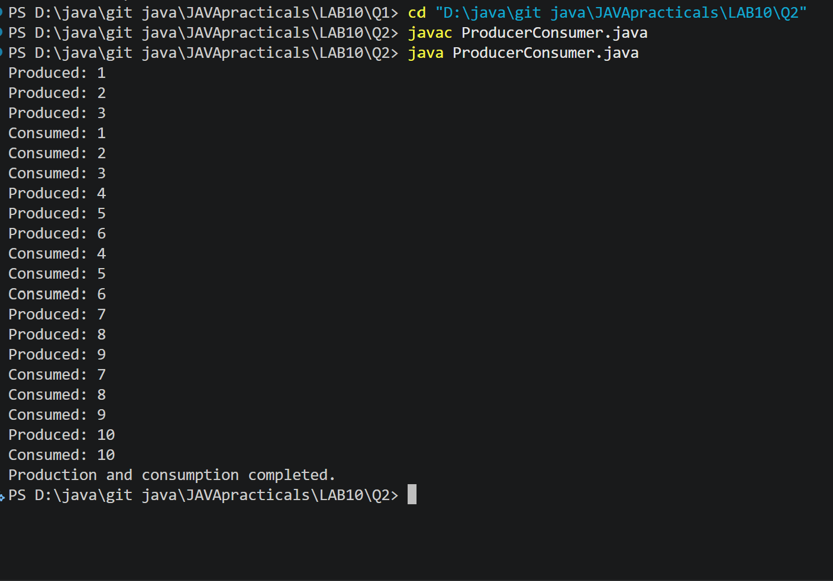
PROBLEM3 | 3. (For Advanced Learners – home) Reproduce a deadlock between two threads that lock  two objects in opposite order, then remove it with a consistent lock order. Choose the  scenario yourself.
CODE | public class DeadlockDemo {  static final Object lockA = new Object();  static final Object lockB = new Object();  public static void main(String[] args)  throws InterruptedException {  Thread t1 = new Thread(() -> {  synchronized (lockA) {  System.out.println("Thread 1 locked A");  try {  Thread.sleep(100);  } catch (InterruptedException e) {  Thread.currentThread().interrupt();  return;  }  synchronized (lockB) {  System.out.println("Thread 1 locked B");  }  }  });  Thread t2 = new Thread(() -> {  synchronized (lockB) {  System.out.println("Thread 2 locked B");  try {  Thread.sleep(100);  } catch (InterruptedException e) {  Thread.currentThread().interrupt();  return;  }  synchronized (lockA) {  System.out.println("Thread 2 locked A");  }  }  });  t1.start();  t2.start();  t1.join();  t2.join();  System.out.println("Program completed.");  }  }
OUTPUT | 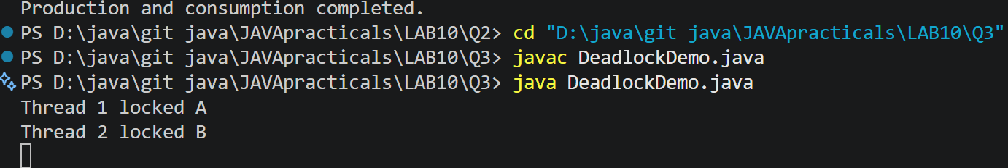

PRACTICAL - 11

PROBLEM1 | 1. Save/load: make a small class Serializable, save an array of its objects to a file with  ObjectOutputStream, then read it back into fresh objects and confirm the values survived.  Mark one field transient and show it is not saved.
CODE | import java.io.*;  class Student implements Serializable {  int id;  String name;  transient String password;  Student(int id, String name, String password) {  this.id = id;  this.name = name;  this.password = password;  }  }  public class SerializationDemo {  public static void main(String[] args) {  try {  Student[] students = {  new Student(1, "Bhavya", "abc123"),  new Student(2, "Rahul", "xyz456")  };  // Save objects to file  ObjectOutputStream out =  new ObjectOutputStream(new FileOutputStream("student.dat"));  out.writeObject(students);  out.close();  // Read objects from file  ObjectInputStream in =  new ObjectInputStream(new FileInputStream("student.dat"));  Student[] loadedStudents = (Student[]) in.readObject();  in.close();  // Display loaded objects  for (Student s : loadedStudents) {  System.out.println("ID: " + s.id);  System.out.println("Name: " + s.name);  System.out.println("Password: " + s.password);  System.out.println();  }  } catch (Exception e) {  System.out.println(e);  }  }  }
OUTPUT | 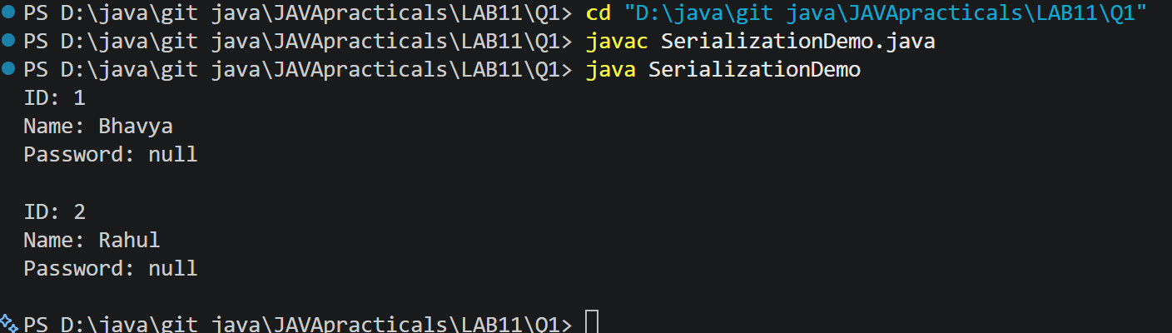
PROBLEM2 | 2. Log analyzer: create a few text files, then use Path/Files to read each line by line and  count the total lines and how many contain a keyword across all files; also print each  file’s size from its attributes.
CODE | import java.io.*;  import java.nio.file.*;  import java.nio.file.attribute.BasicFileAttributes;  import java.util.*;  public class LogAnalyzer {  public static void main(String[] args) {  try {  // Create sample text files  Files.write(Paths.get("log1.txt"), Arrays.asList(  "Application started",  "Error: File not found",  "User logged in"  ));  Files.write(Paths.get("log2.txt"), Arrays.asList(  "Connection successful",  "Error: Connection failed",  "Application closed"  ));  int totalLines = 0;  int keywordCount = 0;  String keyword = "Error";  String[] fileNames = {"log1.txt", "log2.txt"};  for (String fileName : fileNames) {  Path path = Paths.get(fileName);  // Read file line by line  List<String> lines = Files.readAllLines(path);  totalLines += lines.size();  for (String line : lines) {  if (line.contains(keyword)) {  keywordCount++;  }  }  // Get file attributes  BasicFileAttributes attr =  Files.readAttributes(path, BasicFileAttributes.class);  System.out.println("File: " + fileName);  System.out.println("Size: " + attr.size() + " bytes");  System.out.println();  }  System.out.println("Total lines: " + totalLines);  System.out.println("Lines containing '" + keyword +  "': " + keywordCount);  } catch (IOException e) {  System.out.println("Error: " + e.getMessage());  }  }  }
OUTPUT | 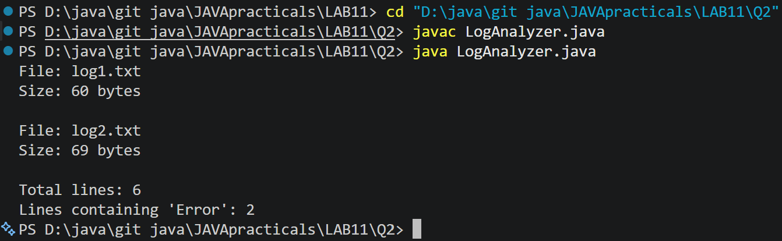
PROBLEM3 | 3. (For Advanced Learners – home) Walk a folder tree with NIO and produce a report of  the files it contains (name, size, modified time), writing the summary to a file; decide  what to include.
CODE | import java.io.*;  import java.nio.file.*;  import java.nio.file.attribute.BasicFileAttributes;  import java.time.Instant;  public class FolderTreeReport  {  public static void main(String[] args)  {  Path folder = Paths.get("sample");  Path report = Paths.get("report.txt");  try  {  // Create a sample folder and files  Files.createDirectories(folder.resolve("subfolder"));  Files.write(folder.resolve("file1.txt"),"Hello Java".getBytes());  Files.write(folder.resolve("subfolder/file2.txt"),"Java NIO".getBytes());  try (BufferedWriter writer =Files.newBufferedWriter(report))  {  writer.write("FOLDER TREE REPORT");  writer.newLine();  writer.write("------------------");  writer.newLine();  Files.walkFileTree(folder,new SimpleFileVisitor<Path>()  {  @Override  public FileVisitResult visitFile(Path file, BasicFileAttributes attrs)  throws IOException  {  writer.write("Name: " +folder.relativize(file));  writer.newLine();  writer.write("Size: " + attrs.size() + " bytes");  writer.newLine();  writer.write("Modified: " + Instant.ofEpochMilli(attrs.lastModifiedTime().toMillis()));  writer.newLine();  writer.newLine();  return FileVisitResult.CONTINUE;  }  }  );  }  System.out.println("Report created successfully!");  System.out.println("Report file: report.txt");  }  catch (IOException e)  {  System.out.println("Error: " + e.getMessage());  }  }  }
OUTPUT | 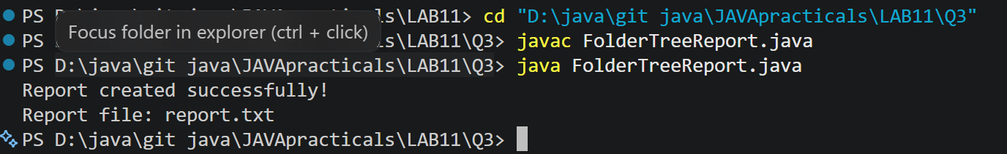

PRACTICAL - 12

PROBLEM1 | 1. Word frequency: split a paragraph into words, count each in a HashMap, and print the  words sorted by frequency (highest first) using a Comparator.
CODE | import java.util.*;  public class WordFrequency  {  public static void main(String[] args)  {  String paragraph = "java is easy and java is powerful";  String[] words = paragraph.toLowerCase().split("\\s+");  HashMap<String, Integer> map = new HashMap<>();  for (String word : words)  {  map.put(word, map.getOrDefault(word, 0) + 1);  }  List<String> list = new ArrayList<>(map.keySet());  Collections.sort(list, new Comparator<String>()  {  public int compare(String a, String b)  {  return map.get(b).compareTo(map.get(a));  }  }  );  System.out.println("Word Frequency:");  for (String word : list)  {  System.out.println(word + " : " + map.get(word));  }  }  }
OUTPUT | 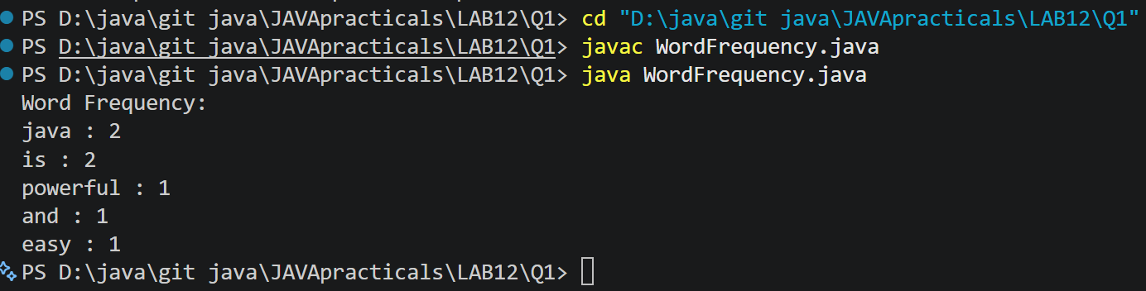
PROBLEM2 | 2. Unique visitors: from a list of login names with repeats, use a HashSet to count unique  users and a LinkedHashSet to keep first-seen order; print the unique count and the first  three distinct names.
CODE | import java.util.*;  public class UniqueVisitors  {  public static void main(String[] args)  {  String[] logins = {  "Bhavya", "Rahul", "Jay", "Bhavya",  "Het", "Rahul", "Fenil"  };  HashSet<String> uniqueUsers = new HashSet<>();  LinkedHashSet<String> orderedUsers = new LinkedHashSet<>();  for (String name : logins) {uniqueUsers.add(name);orderedUsers.add(name);}  System.out.println("Unique users count: " + uniqueUsers.size());  System.out.println("First three distinct users:");  int count = 0;  for (String name : orderedUsers)  {  if (count == 3)  {  break;  }  System.out.println(name);  count++;  }  }  }
OUTPUT | 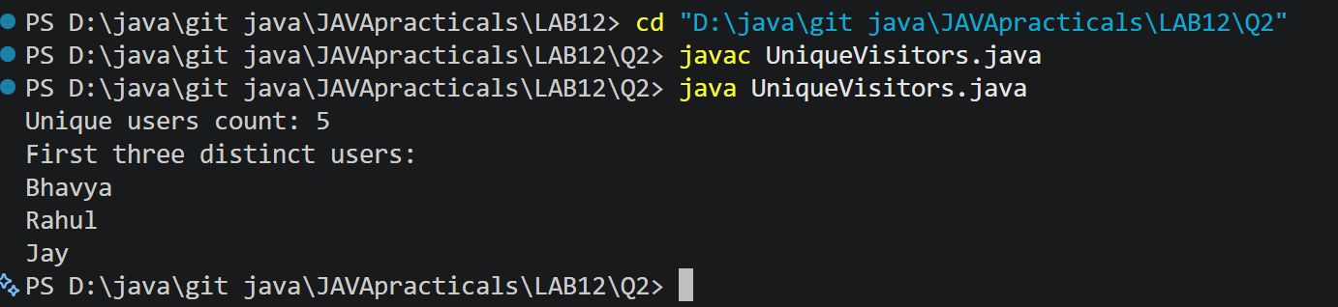
PROBLEM3 | 3. (For Advanced Learners – home) Build a leaderboard from player scores held in a Map  and print the top-N sorted by score (ties broken by name); choose the data and sorting  details.
CODE | import java.util.*;  public class Leaderboard  {  public static void main(String[] args)  {  Map<String, Integer> scores = new HashMap<>();  scores.put("Bhavya", 95);  scores.put("Rahul", 88);  scores.put("Jay", 95);  scores.put("Het", 78);  scores.put("Fenil", 88);  List<Map.Entry<String, Integer>> players =new ArrayList<>(scores.entrySet());  Collections.sort(players, new Comparator<Map.Entry<String, Integer>>()  {  public int compare(Map.Entry<String, Integer> p1,Map.Entry<String, Integer> p2)  {  int result = p2.getValue().compareTo(p1.getValue());  if (result == 0)  {  return p1.getKey().compareTo(p2.getKey());  }  return result;  }  }  );  int topN = 3;  System.out.println("Top " + topN + " Players:");  System.out.println("-------------------");  for (int i = 0; i < Math.min(topN, players.size()); i++)  {  Map.Entry<String, Integer> player = players.get(i);  System.out.println(player.getKey() + " - " + player.getValue());  }  }  }
OUTPUT | 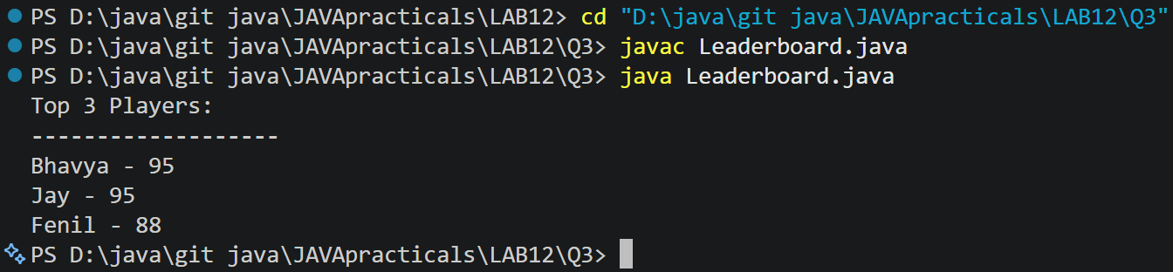

PRACTICAL - 13

PROBLEM1 | Generic containers: a generic Box<T> with get/set and a Pair<A,B>; use them with different types to show type safety without casts, and write a generic method that returns the first element of any array.
CODE | class Box<T>  {  private T value;  void set(T value)  {  this.value = value;  }  T get()  {  return value;  }  }  class Pair<A, B>  {  private A first;  private B second;  Pair(A first, B second)  {  this.first = first;  this.second = second;  }  A getFirst()  {  return first;  }  B getSecond()  {  return second;  }  }  public class ContainerDemo  {  static <T> T first(T[] values)  {  if (values.length == 0)  {  throw new IllegalArgumentException("Empty array");  }  return values[0];  }  public static void main(String[] args)  {  Box<String> names = new Box<>();  names.set("Bhavya");  Box<Integer> marks = new Box<>();  marks.set(90);  Pair<String, Integer> pair =new Pair<>(names.get(), marks.get());  System.out.println(pair.getFirst() + " " + pair.getSecond());  System.out.println(first(new String[]{"Java", "Python"}));  System.out.println(first(new Integer[]{10, 20}));  }  }
OUTPUT | 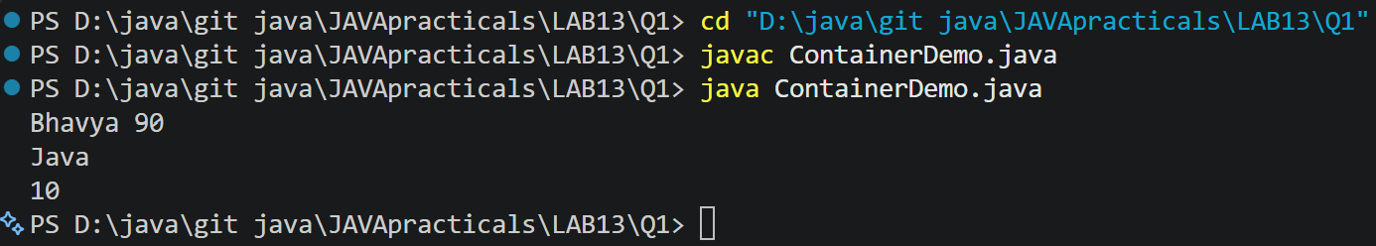
PROBLEM2 | Bounded stats: a generic method <N extends Number> double average(N[] values) that works for Integer[], Double[] and Long[]; note why it refuses non-Number types.
CODE | public class Stats  {  static <N extends Number> double average(N[] values)  {  if (values.length == 0)  {  throw new IllegalArgumentException("Empty array");  }  double sum = 0;  for (N n : values)  {  sum += n.doubleValue();  }  return sum / values.length;  }  public static void main(String[] args)  {  System.out.println(average(new Integer[]{10, 20, 30}));  System.out.println(average(new Double[]{1.5, 2.5}));  System.out.println(average(new Long[]{100L, 200L}));  }  }
OUTPUT | 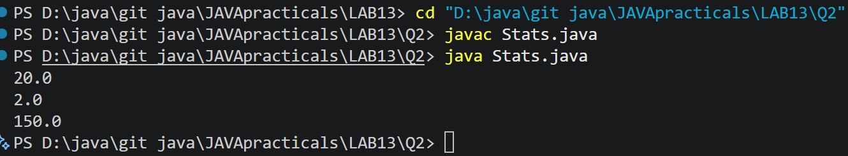
PROBLEM3 | (For Advanced Learners – home) Implement a small generic container of your choice (e.g. a stack) backed by an array, reuse it for two different types, and handle the empty case sensibly.
CODE | import java.util.EmptyStackException;  class Stack<T>  {  private Object[] data;  private int size;  Stack(int capacity)  {  data = new Object[capacity];  }  void push(T item)  {  if (size == data.length)  {  throw new IllegalStateException("Stack full");  }  data[size++] = item;  }  @SuppressWarnings("unchecked")  T pop()  {  if (size == 0)  {  throw new EmptyStackException();  }  T item = (T) data[--size];  data[size] = null;  return item;  }  }  public class StackDemo  {  public static void main(String[] args)  {  Stack<Integer> numbers = new Stack<>(3);  numbers.push(10);  numbers.push(20);  Stack<String> names = new Stack<>(2);  names.push("Bhavya");  System.out.println(numbers.pop());  System.out.println(names.pop());  try  {  names.pop();  }  catch (EmptyStackException e)  {  System.out.println("Stack empty");  }  }  }
OUTPUT | 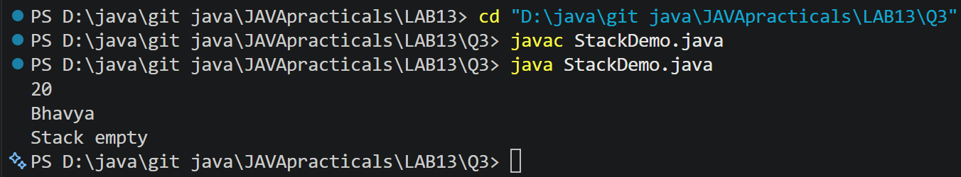

PRACTICAL – 14

1) | Assemble and test: build a tiny layered app (a model, a service using an ArrayList, and a menu main), then write two or three JUnit @Test methods checking that adding increases the count and an invalid action throws — practice before testing MiniBank.
 | Item.java
CODE | public class Item {  private String name;  public Item(String name) {  this.name = name;  }  public String getName() {  return name;  }  }
 | ItemService.java
CODE | import java.util.ArrayList;  public class ItemService {  private ArrayList<Item> items = new ArrayList<>();  public void add(String name) {  if (name == null || name.isBlank()) {  throw new IllegalArgumentException("Name required");  }  items.add(new Item(name));  }  public int count() {  return items.size();  }  public ArrayList<Item> all() {  return new ArrayList<>(items);  }  public void invalidAction() {  throw new IllegalArgumentException("Invalid action");  }  }
 | ItemApp.java
CODE | import java.util.Scanner;  public class ItemApp {  public static void main(String[] args) {  ItemService service = new ItemService();  Scanner sc = new Scanner(System.in);  while (true) {  System.out.println("\n1. Add");  System.out.println("2. List");  System.out.println("3. Exit");  System.out.print("Enter choice: ");  String choice = sc.nextLine();  try {  switch (choice) {  case "1":  System.out.print("Enter item name: ");  service.add(sc.nextLine());  System.out.println("Item added successfully");  break;  case "2":  for (Item item : service.all()) {  System.out.println(item.getName());  }  break;  case "3":  System.out.println("Exiting...");  sc.close();  return;  default:  service.invalidAction();  }  } catch (IllegalArgumentException e) {  System.out.println(e.getMessage());  }  }  }  }
 | ItemServiceTest.java
CODE | import org.junit.jupiter.api.Test;  import static org.junit.jupiter.api.Assertions.*;  public class ItemServiceTest {  @Test  void addIncreasesCount() {  ItemService service = new ItemService();  service.add("Book");  assertEquals(1, service.count());  }  @Test  void blankNameThrowsException() {  ItemService service = new ItemService();  assertThrows(  IllegalArgumentException.class,  () -> service.add("")  );  }  @Test  void invalidActionThrowsException() {  ItemService service = new ItemService();  assertThrows(  IllegalArgumentException.class,  () -> service.invalidAction()  );  }  }
OUTPUT | 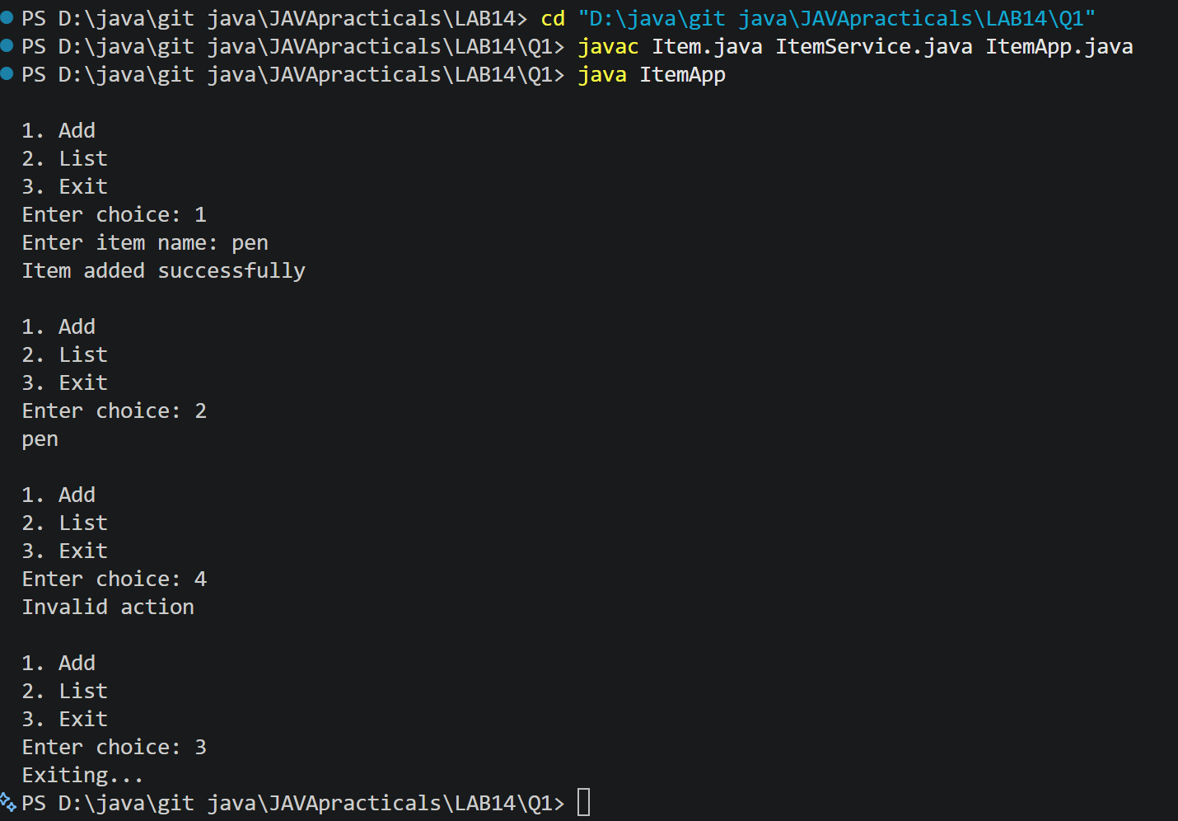
2) | (For Advanced Learners – home) Organise that app into packages, build a runnable JAR,  and add a test that saves and reloads its data unchanged.
 | Sec/model/Item.java
Code | package app.model;  import java.io.Serializable;  public class Item implements Serializable {  private static final long serialVersionUID = 1L;  private String name;  public Item(String name) {  this.name = name;  }  public String getName() {  return name;  }  @Override  public String toString() {  return name;  }  }
 | Src/service/ItemService.java
Code | package app.service;  import app.model.Item;  import java.io.*;  import java.nio.file.*;  import java.util.ArrayList;  import java.util.List;  public class ItemService {  private ArrayList<Item> items = new ArrayList<>();  public void add(String name) {  if (name == null || name.isBlank()) {  throw new IllegalArgumentException("Name required");  }  items.add(new Item(name));  }  public int count() {  return items.size();  }  public ArrayList<Item> all() {  return new ArrayList<>(items);  }  public void save(Path file) throws IOException {  try (ObjectOutputStream out = new ObjectOutputStream(  Files.newOutputStream(file))) {  out.writeObject(items);  }  }  @SuppressWarnings("unchecked")  public void load(Path file)  throws IOException, ClassNotFoundException {  try (ObjectInputStream in = new ObjectInputStream(  Files.newInputStream(file))) {  Object data = in.readObject();  if (!(data instanceof ArrayList<?>)) {  throw new IOException("Invalid data file");  }  ArrayList<?> loaded = (ArrayList<?>) data;  for (Object obj : loaded) {  if (!(obj instanceof Item)) {  throw new IOException("Invalid item data");  }  }  items = new ArrayList<>((List<Item>) loaded);  }  }  }
 | Src/app/ItemApp.java
Code | package app.main;  import app.model.Item;  import app.service.ItemService;  import java.nio.file.Path;  import java.nio.file.Paths;  import java.util.Scanner;  public class ItemApp {  public static void main(String[] args) {  ItemService service = new ItemService();  Path file = Paths.get("items.dat");  try {  if (java.nio.file.Files.exists(file)) {  service.load(file);  System.out.println("Data loaded successfully.");  }  } catch (Exception e) {  System.out.println("Could not load data: " + e.getMessage());  }  try (Scanner sc = new Scanner(System.in)) {  while (true) {  System.out.println("\n1. Add item");  System.out.println("2. List items");  System.out.println("3. Save data");  System.out.println("4. Exit");  System.out.print("Enter choice: ");  String choice = sc.nextLine();  try {  switch (choice) {  case "1":  System.out.print("Enter item name: ");  service.add(sc.nextLine());  System.out.println("Item added.");  break;  case "2":  for (Item item : service.all()) {  System.out.println(item.getName());  }  break;  case "3":  service.save(file);  System.out.println("Data saved successfully.");  break;  case "4":  System.out.println("Goodbye!");  return;  default:  System.out.println("Invalid choice.");  }  } catch (Exception e) {  System.out.println("Error: " + e.getMessage());  }  }  }  }  }
 | test/ItemServiceTest.java
Code | import app.model.Item;  import app.service.ItemService;  import org.junit.jupiter.api.Test;  import java.nio.file.Files;  import java.nio.file.Path;  import static org.junit.jupiter.api.Assertions.*;  public class ItemServiceTest {  @Test  void saveAndLoadPreservesData() throws Exception {  Path file = Files.createTempFile("items", ".dat");  try {  ItemService original = new ItemService();  original.add("Book");  original.add("Pen");  original.save(file);  ItemService restored = new ItemService();  restored.load(file);  assertEquals(original.count(), restored.count());  assertEquals("Book", restored.all().get(0).getName());  assertEquals("Pen", restored.all().get(1).getName());  } finally {  Files.deleteIfExists(file);  }  }  @Test  void addIncreasesCount() {  ItemService service = new ItemService();  service.add("Book");  assertEquals(1, service.count());  }  @Test  void blankNameThrowsException() {  ItemService service = new ItemService();  assertThrows(  IllegalArgumentException.class,  () -> service.add(" ")  );  }  }
Output | 

